|  |  |
| --- | --- |
|  | **Qatar University**  **College of Engineering**  **Department of Computer Science and Engineering** |

Senior Project Report

Monitoring Vital Data Using Sensors for Mobile Application Using Cloud Computing: IoT for Healthcare

Project Group Members:

Diae Moharrar 201303866

Reem Al-Hajri 201205918

Hajar Hosseini 201203920

Maryam Al-Sahoti 201300985

**Supervisor**: Dr.Mohammed Samaka

**2017-2018**

This project report is submitted to the Department of Computer Science and Engineering of Qatar University in partial fulfillment of the requirements of the Senior Project course.

# **Declaration**

This report has not been submitted for any other degree at this or any other University. It is solely the work of us except where cited in the text or the Acknowledgements page. It describes work carried out by us for the capstone design project. We are aware of the university’s policy on plagiarism and the associated penalties and we declare that this report is the product of our own work.

Student: **Diae Moharrar** Date:

Signature:

Student**: Reem Al-Hajri**  Date:

Signature:

Student: **Hajar Al-Hosseini**  Date:

Signature:

Student: **Maryam Al-Sahoti** Date:

Signature:

# **Abstract**

Internet of Things (IoT) is a networking paradigm that comprises of various components and physical systems such as vehicles, home appliances, and other items embedded with electronics, software, sensors, actuators and others. These components are connected together over a network where data can be transferred easily without the need of human-to-human or human-to-computer interaction.

The aim of our project is to demonstrate the usability of IoT in the medical field. We will demonstrate the application of IoT to monitor patient’s health-related data remotely by using various sensors, such as blood pressure(BP) sensor, electrocardiogram(ECG) sensor, body temperature sensor and pulse and oxygen in blood(SPO2) sensorby connecting these sensors to an Arduino board.

The patient’s data can be continuously monitored using the sensors. Then, the data is shared to a mobile phone that syncs the data to the cloud, and can be easily fetched by doctors or relatives immediately across the Internet, if anomaly is detected or any risk to patient’s life is perceived with the current sensed data. We propose to maintain the health record of the patient in a database, which can be shared with the doctor along with the latest readings from the sensors. This can help doctor to access the situation more accurately and perform the accurate diagnosis. If any abnormal data occurred, a notification will be sent to the user, his/her family relatives, a doctor, and the emergency according to the cases of the abnormalities. An immediate response might save the patient’s life, it anomaly in ECG is an impending heart-attack.

In the second phase of the project, we will be building a prototype according to what we mentioned in this Design Report.

# **Acknowledgment**

Working on this project, “E-Health Sensors Monitoring for Mobile Application Using Cloud Computing: IoT for Healthcare”, was a source of immense knowledge for us.

We would like to express our sincere gratitude to our supervisors Dr. Mohammed Samaka and Dr. Deval Bhamare for providing their invaluable guidance, comments and suggestions throughout the course of the project.

We would specially thank Dr. Mohammed Samaka for constantly motivating us to work harder and Dr. Deval Bhamare for giving us his comments to improve the report toward the best.

We would grab the chance to thank Dr. Waleed Khaled and Dr. Alaa Kanbour for their guidance and kind advices that effectively contributed our system solution.

We would like also to thank our families, friends and colleagues who supported and encouraged us to complete this project.

Table of Contents

Declaration ii

Abstract iii

Acknowledgment iv

List of Figures vii

List of tables ix

1. Introduction and Motivation 1

1.1. Problem statement 1

1.2. Project objectives 1

1.3. Project significance 2

2. Related works 3

2.1.1. Comparative Analysis 8

3. Requirements analysis 11

3.1. Functional requirements 11

3.2. Non-functional requirements 12

3.3. Design constraints 13

3.4. Design standards 14

3.5. Professional Code of Ethics 15

3.6. Assumptions 16

4. Proposed solution 16

4.1. Solution overview 16

4.2. High level architecture Discussion 22

4.3. Hardware/software used 26

4.3.1 Hardware 26

4.3.2 Software 31

4.3.3 Security Means and Impacts 33

4.4. Hardware design 37

4.4.1. Hardware Components 37

4.4.2. Circuit Diagram 37

4.4.3. Hardware Cost 39

4.5. Software design 39

4.5.1. Android Studio Application Development 39

4.5.2. Arduino IDE 42

4.6. Structural model 47

4.7. Database design 47

4.8. User interface design 50

5. Implementation 53

5.1. Android application development environment 53

5.1.1. Connecting android application to firebase cloud 53

5.1.2. Implementing patient User interface 54

5.1.3. Implementing doctor’s User interface 56

5.2. Hardware and Software Implementation for ESP8266 NodeMCU 56

5.2.1. Connecting ESP8266 NodeMCU to WIFI network and Firebase cloud 56

5.2.2. Connecting 4x4 Keypad and LCD display(16x2) to ESP8266 NodeMCU 56

5.3. Hardware and Software Implementation for Arduino Uno 58

5.4. Firebase cloud 59

5.4.1. Firebase real time database 61

5.4.2. Firebase cloud functions 62

6. Testing 65

6.1. System Connectivity Testing 65

6.1.1. Testing the connection of ESP8266 NodeMCU to a local wireless Network 66

6.1.2. Testing the connection of the ESP8266 NodeMCU to the Firebase cloud 66

6.1.3. ESP8266 NODEMCU sending sensors data to firebase 67

6.1.4. Application Receiving sensors data from firebase 68

6.2. System Usability Testing 70

6.3. Design constraints evaluation 72

7. Evaluation of the impact of the engineered solution 75

8. Conclusion 77

9. Future Work 77

10. Student reflections 78

10.1. Diae’s reflection: 78

10.2. Reem’s reflection: 79

10.3. Hajar’s reflection: 79

10.4. Maryam’s reflection: 80

References 81

Appendix A - Project plan 84

A.1. Project milestones 84

A.2. Project timeline 85

A.3. Anticipated risks 86

Other Appendices 87

# **List of Figures**

Figure 1: MySignals e-health platform 4

Figure 2: Heart-Rate sensor 5

Figure 3: LM35 sensor 6

Figure 4: SPO2 sensor 6

Figure 5: Body Temperature sensor 7

Figure 6: Breathing sensor 7

Figure 7: ECG sensor 8

Figure 8 : Rasha and Talal’s research papers hight-level architecture 12

Figure 9 : Kakria and Kitipaqang research paper high-level architecture 13

Figure 10 : BSN high-level architecture 14

Figure 11 : Chralampos and Ilias’s research paper high-level architecture 15

Figure 12 : Marcel research paper high-level architecture 16

Figure 13 : Salomi’s research paper high-level architecture 17

Figure 14 : Use-Case Diagram 21

Figure 15 : Waterfall diagram 29

Figure 16: High Level Architecture 31

Figure 17 : System Circuit Diagram 39

Figure 18 : Application Logic Flow Chart 42

Figure 19 : ESP8266 NodeMCU Flowchart 45

Figure 20 : Arduino Uno Flowchart 47

Figure 21 : doctors DB 48

Figure 22 : Sensors Readings DB 49

Figure 23 : Temperature sensor node (node ’1’) and the child nodes under 49

Figure 24 : Temperature sensor single reading information 50

Figure 25 : ‘users’ DB and child nodes 51

Figure 26 : Single user node information 51

Figure 27 : Dependencies added in build.gradle file in Android 55

Figure 28 : userID chlild under users parent node 56

Figure 29 : NodeMCU with 4x4 keypad and 16x2 LCD 59

Figure 30 : My-signals shield above Arduino Uno 60

Figure 31 : Create Gmail account 61

Figure 32 : Create new project in Firebase 61

Figure 33 : Firebase console 62

Figure 34 : Firebase database rules 62

Figure 35 : Firebase database structure 63

Figure 36 : Firebase installation command 63

Figure 37 : SPO2 database structure 64

Figure 38 : Weight database structure 65

Figure 39 : Doctor Notification 65

Figure 40 : Firebase Cloud Functions Flowchart Diagram 66

Figure 41 : Before connecting to network 67

Figure 42 : After connecting to the network 67

Figure 43 : Connection to firebase 68

Figure 44 : New Device ID added in firebase 68

Figure 45 : Average time connection 70

Figure 46 : Users impression on MediCheck system 72

# **List of tables**

Table 1. Cryptography Algorithms 11

Table 2. Analysis Table 17

Table 3. Technical Design constraints 22

Table 4. Practical design constraints 23

Table 5. Hardware connections description 33

Table 6. Hardware Components 37

Table 7. Software Components 37

Table 8. Hardware Cost 40

Table 9. Android Studio Important Libraries Used 43

Table 10. Use cases brief description 48

Table 11. ESP8266 NodeMCU Arduino IDE libraries 58

Table 12. Arduino Uno Arduino IDE libraries 60

Table 13. ESP8266 Node MCU v0.9 connection time Analysis 69

Table 14. Application connection time Analysis 70

Table 15. Technical design constraints 74

Table 16. Practical design constraints 76

Table 17. Evaluation of Engineering Impact 77

Table 18. Project milestones 86

Table 19. Project timeline 87

Table 20. Project timeline-legend 87

Table 21. Anticipated risks 87

# **Introduction and Motivation**

## Problem statement

Cardiovascular disease is the leading cause of death globally, representing 30 percent of all deaths. [1] As these statistics are increasing in the past few years in Qatar; 12.2% of deaths are due to Cardiovascular disease in 2011, 12.1% of deaths are due to the same disease in 2012, and 12.9% in 2013 [2], a solution to decrease the number of deaths due to cardiovascular disease and other chronic diseases in Qatar must be found. This is the motivation of our project; finding a way to help health providers reach patients having chronic diseases in case of emergency as quickly as possible and providing missing important health related data to doctors by saving this data through the internet to be used whenever needed.

In order to increase heart-disease patients’ life expectancy, a health device can be available to check critical health parameters, such as SPO2, BP and other, easily since some patients need to periodic checkups on their health states, this solution could save them time. Moreover, patients must be reached quickly and supervised by health providers in case an emergency has occurred, especially those who tend to live independently away from any family relative or friend, such as elderly people and students who are studying abroad.

For our project, we are aiming to use IoT technology using cloud-based applications. The main reason we chose cloud-based applications is that it offers a computation and analysis capabilities, as well as an online database. This way we ensure scalability in our system as well as an easy management of data to insure privacy by encrypting and decrypting the data. Moreover, IoT technology is used to connect all the hardware together; sensors, microcontroller and mobile device, to ensure an easy transfer of data without the need of human-to-human or human-to-computer interaction

The challenge of our project is to process the patient’s vital data in cloud. Also, our main challenge is providing a secure and private network through encrypting and decrypting the data.

## Project objectives

The project objectives are set by the team as follows:

* Develop a health monitoring system that measures several health parameters of the patient and sends them through IOT cloud.
* Use IOT cloud-based application to provide communication between end-users, save and analyze data in the could for further use by the end-user.
* Establish a reliable and secure connection to and from the IOT cloud. Ensure privacy and security of the patient’s data.
* Build a mobile application at the end-user side to view the readings of the sensors and the current status of the patient.

## Project significance

Our project provides a health device to read critical health parameters; such as SPO2, BP and others, using sensors to easily check self-health states on the go without the need of a nurse. Also, the solution provides direct connectivity between patient sensors, patient’s cell phone and doctor cell phone using cloud-based applications, and an online database for the data to be accessed easily any time by the doctor when needed. Furthermore, patients are easily reached when an urgent direct interaction is needed.

Such a system is going to be a great initiative for Qatar and the region as a whole, introducing something that might be used worldwide, as we will be focusing on ensuring privacy of the users’ data and good connectivity through the cloud, thus helping Qatar reach its 2030 vision by advancing healthcare as one of the pillars of the Human Development. A stimulating business climate will be capable of attracting foreign funds and technology and integrated system of healthcare offering high quality services through public and private institutions operating under the direction of a national health policies that sites and monitors standards for social, economic, administration and technical aspects of health care. This is why we are aiming to draw people’s awareness through our project of the importance of the daily check-up of an individual’s health states.

In this project, we use cloud computing, for it provides an easy internet-based connectivity between the hardware; sensors and users cell phones, and online database to ensure scalability and availability of data whenever needed. Also, we have chosen wireless communications to insure easy use of our device, and a mobile application is needed to abstract the complexity of our system from the user.

The interest of doing such project came from the importance of if in the heart-disease patients’ life. Also, having the knowledge about IoT technology and cloud-based applications can help us get a good start in this field, promising us a better career.

# **Related works**

## In this section, we present some papers and research efforts, we investigated that are closely related to our project, as well as we focus on the components used in each paper/project.

* Rasha, Talal & Hameed [12] concentrated on collecting the patient’s information using some sensors. They have used four sensors related to health care monitoring such as electrocardiogram sensor (ECG), body temperature sensor, pulse rate sensor and oxygen in blood sensor (SPO2). All these sensors are grouped and connected to E-health sensor platformwhich is controlled by Arduino Uno, as well as the user’s data is fetched form that platform.

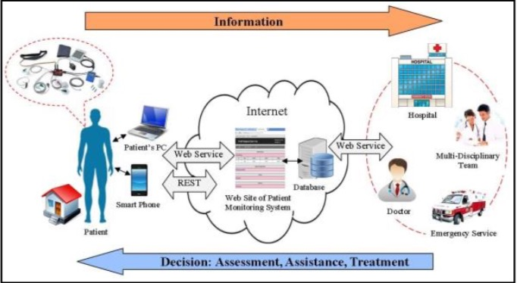

Figure 8 : Rasha and Talal’s research papers hight-level architecture

* Kakria and Kitipawang [13] have developed a wearable sensor to detect underlying heart conditions on real-time by measuring heart rate, blood pressure and body temperature. The wearable sensor contains adaptive alarm system which notifies the doctor in case of emergency, and it has a location record so the doctor can immediately reach to the patient in case of emergency. In real-time, the data is transmitted from wearable sensor to android listening port. In addition to the module it contains the medical history of individual patient after getting registered at Android listening port device.

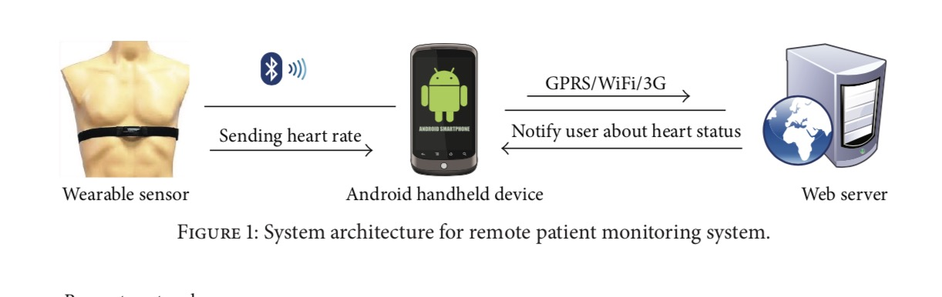

Figure 9 : Kakria and Kitipaqang research paper high-level architecture

* The next related work is BSN-Care [14]. Body Sensor Network (BSN) is composed of wearable and implantable sensors. Each sensor node is integrated with bio-sensors such as Electrocardiogram (ECG), Electromyography (EMG), Electroencephalography (EEG), Blood Pressure (BP), and other sensors.   
  The sensors collect the physiological parameters and forward them to a coordinator called Local Processing Unit (LPU), which can a portable device like PDA, smart-phone and others.   
  The LPU works as a router between the BSN nodes and the central server called BSN-Care server, using the wireless communication mediums such as mobile networks 3G/CDMA/GPRS. Besides, when the LPU detects any abnormalities then it provides immediate alert to the person that wearing the bio-sensors.   
  Based on the degree of abnormalities, BSN interact with the family members of the person, local physician, or even emergency unit of a nearby healthcare center.

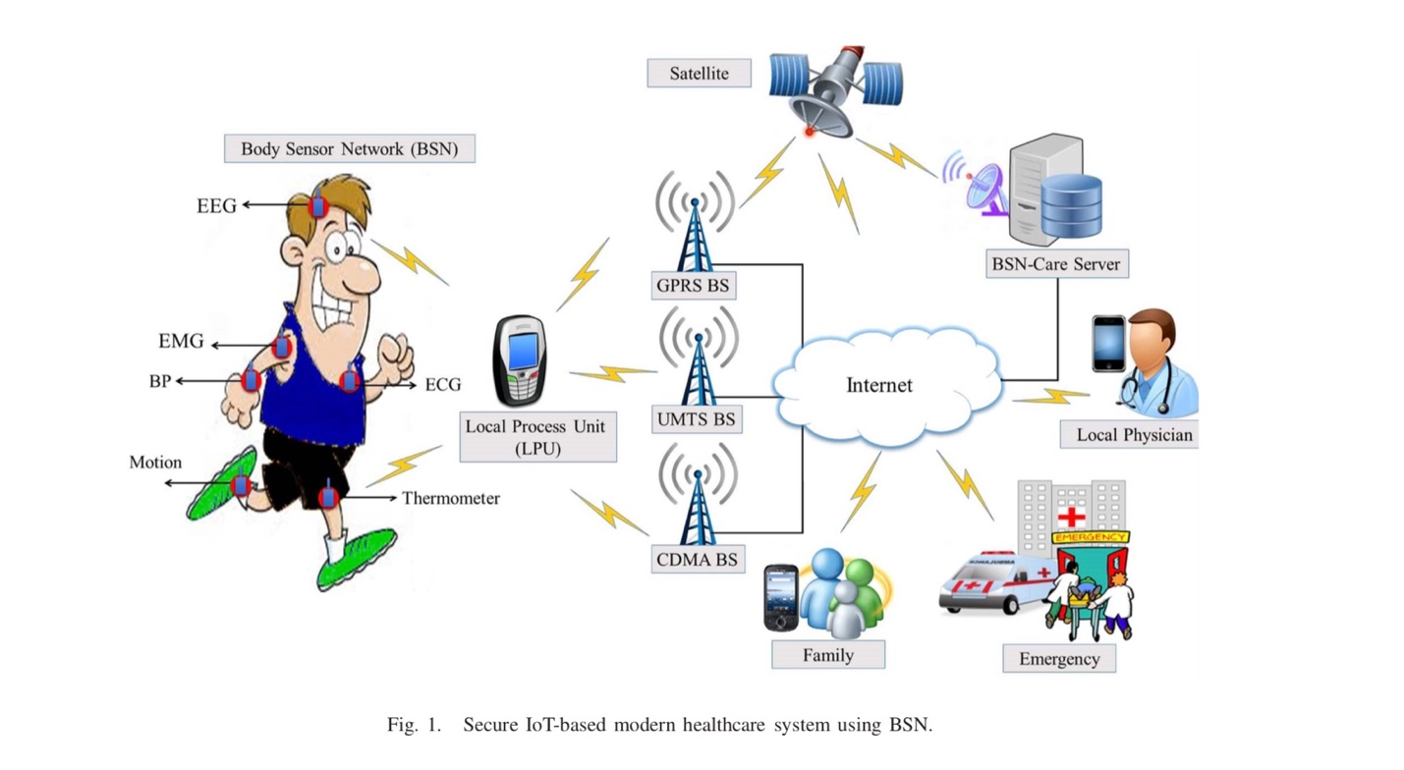

Figure 10 : BSN high-level architecture

* Charalampos and Ilias [15] have developed a Cloud-based system that manages sensor data. Wearable – textile sensors collect bio signals such as ECG, oxygen saturation and temperature from the user, motion data (through accelerometers) and contextual data such as location, ambient temperature, activity status. Depending on the wireless technology used, the data can be forwarded to a mobile phone or directly to the Cloud infrastructure utilizing established techniques for IoT communication. Appropriate interfaces enable the data dissemination to external applications (like medical record systems or emergency detection platforms) and a web-based application provides the essential data real-time monitoring and management.

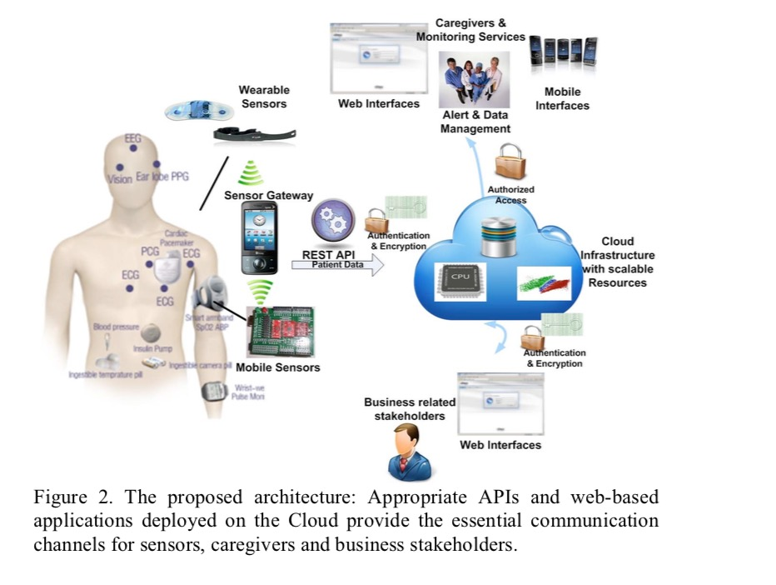

Figure 11 : Chralampos and Ilias’s research paper high-level architecture

* Marcel Winandy [16] discussed in this paper the security and privacy of modern disturbed e-health systems. The aim of his paper is to address the client platform security, which is considered a critical part for the overall security e-health systems. The solution provides client platform security and properly combines this with network security concepts. “For a secure platform on the client platform, a security kernel is running on top of the hardware, providing isolated virtual machines for applications and conventional operating systems. Moreover, there is a TVD proxy for each TVD, which manages the TVD on the client and configures the security kernel according to the TVD policy. Furthermore, the client platform contains a trusted hardware component which can be used for the verification of the integrity of the software on the client (in particular, the security kernel). The most widespread trusted hardware component is the Trusted Platform Module (TPM) [17]. Currently, it is usually implemented as a separate chip integrated on the mainboard of a computer.” (Winandy).

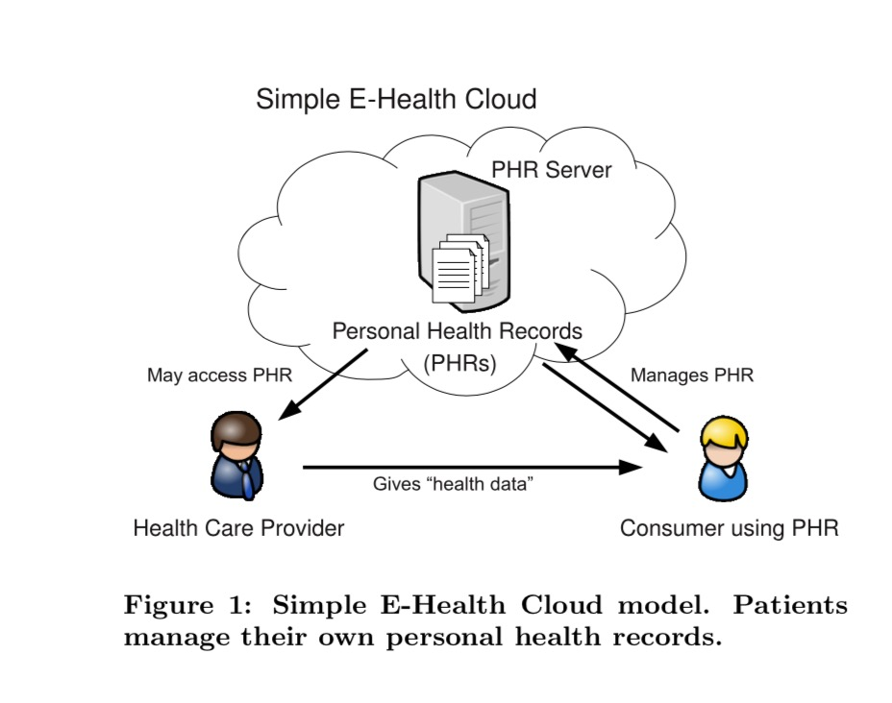

Figure 12 : Marcel research paper high-level architecture

* Salomi [18] used two sensors in his project; one to measure heart rate and one to measure body temperature. Heart rate is measured by using two numbers. The first number is called systolic heart rate which measures the pressure in our blood vessels when the heart beats. The second number is called diastolic heart rate which measures the pressure in our blood vessels when the heart rests between beats. Reading data for heart rate, normal heart rate when systolic rate is lesser then 120 mmHg and diastolic rate is lesser than 80 mmHg. High rate, systolic rate is 140 mmHg or more and diastolic rate is 90 mmHg or more. Patient can have a condition called prehypertension when Systolic rate is higher than 120–139 mmHg and diastolic rate is higher than 80–89 mmHg. Body temperature varies from person to person. Normal temperature is 98.6°F (37°C). Abnormal, oral temperature 100.4°F (38°C) to 103.9°F (39.9°C) is fever and 104°F (40°C) and higher is high fever. Armpit (auxiliary) temperature 99.4°F (37.4°C) to 102.9°F (39.4°C) is fever 103°F (39.5°C) and higher is high fever. Finally, ear temperature of less than 97°F (36.1°C) means a low body temperature.

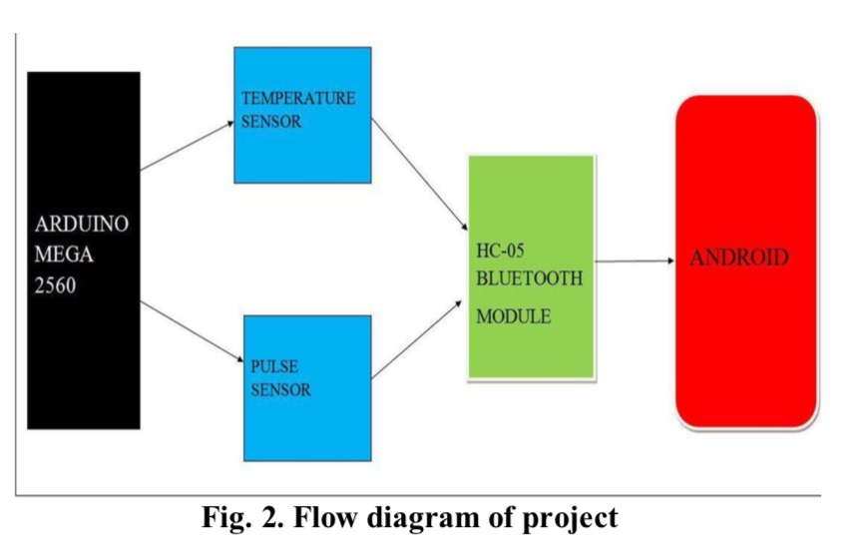

Figure 13 : Salomi’s research paper high-level architecture

### **Comparative Analysis**

In the following, we would like to present a comparative analysis that involves all the above surveyed related works, taking into our consideration the key functional and design aspects, outlined in (Table 2) that could have impact on determining a solution that achieves the objectives of our study.

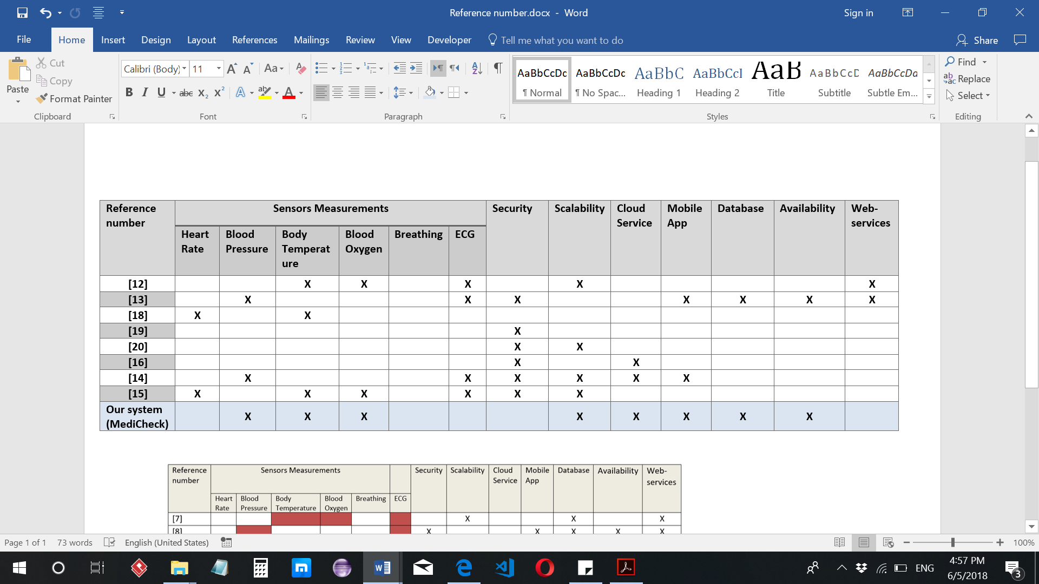

Table 2. Analysis Table

**Sensors:**

In [18], the authors measure two types of data, which are, heart rate and body temperature. Authors mention data table in the paper and whether the output from these sensors is normal or abnormal. Such information will help us in our project to decide if the patient is in a normal state or not. But in [12], the researchers have used more developed sensors, which are, Electrocardiogram sensor, Body Temperature Sensor, and Pulse and Oxygen in Blood Sensor for e-health sensors platform, which has been designed by Cooking Hacks Company. In [13], authors work with sensors like, ECG and Blood Pressure that are grouped as a wearable device without mentioning special sensor name. But, they mention how they detect normal and abnormal data in general for BP. For example, if BP is less than or equal to 120 is normal then no action taken, when the BP is greater than 130 they inform family member, and if no one response and the BP become greater than 160 they inform the doctor and if also no one response, inform emergency.

BSN-Care [14] has used many sensors that are wearable and implantable such as Electrocardiogram (ECG), Electromyography (EMG), Electroencephalography (EEG), BP, etc.

Charalampos and Ilias [15] used heart rate sensors, accelerometer by Polar, oxygen saturation and temperature sensors, and other contextual features such as the user’s location, ambient temperature and activity status.

**Security:**

Security is an important factor in every system. What we mean by security in our project is to have a system, with which the network (as we are sending data wirelessly between nodes) and the data (as the data is considered to be sensitive since it carries information about someone’s own health) are secured by advanced cryptography techniques.

BSN-Care [14] security requirements are divided into two parts: network security and data security. Network security consists of authentication, anonymity and secure localization. Whereas data security comprises data privacy, data integrity and data freshness. As they have mentioned, they used OCB authentication encryption mode for data security, and a proposed lightweight anonymous authentication protocol for the network security, as there is no two-party authentication protocol.

Charalampos and Ilias [15] used appropriate authentication and data encryption mechanisms to secure the communication between the Cloud infrastructure and the rest of their project components. The sensors are secured by an id and the user’s data is encrypted using symmetric encryption techniques. Whereas for the user and the external applications, they are encrypted using more sophisticated techniques such as PKI and digital signature. All of the encryption is done by Jelastic using Java extensions. Data, Arduino and sensors encryption is done by using AES data encryption implemented by java cryptographic extension. In Marcel

Winandy paper [13]has discussed security problems of E-health clouds, and it is focused on technical aspects of processing health-related data of patients. The author also proposed a technical solution to address particularly the end user platform security issue. The author also used Trusted Virtual Domains (TVDs), which has been developed in recent years as a security framework for distributed multi-domain environments that leverages virtualization and trusted computing technologies. The main security features of TVDs are isolated compartments, trust relationships, transparent policy enforcement, and secure communication. Winandy proposed: “structure of a TVD with a client platform and a TVD master (a server for the management of the TVD infrastructure) for each domain. On the client platform, a security kernel is running on top of the hardware, providing isolated virtual machines for applications and conventional operating systems. Moreover, there is a TVD proxy for each TVD, which manages the TVD on the client and configures the security kernel according to the TVD policy. The secure graphical user interface (secure GUI) provides input and output, ensuring that users can always reliably identify with which compartment they are interacting. Furthermore, the client platform contains a trusted hardware Component, the most widespread trusted hardware component is the Trusted Platform Module (TPM). TPMs provide a set of security and cryptographic functions, such as public key encryption, digital signatures, secure key storage, non-volatile memory” (Winday).

Kakria and Kitipawang [13] secured the data by making the data visible to authorized users only.

**Scalability:**

Scalability is an important aspect that allows the growth of the system without affecting current data/users. In our project, it means the ability to have more users, thus more data, without losing any of the current data of existing users we have in our database or causing unnecessary delays.

BSN-Care is a scalable system which can have more users and data, although they did not mention who they save their data in a database.

Charalampos and Ilias [15] are proposing a scalable solution due to the fact that it is a Cloud infrastructure based solution, which provides resources according to utilization and demand.

Ahmed Lounis and his partners [20] presented scalable architecture that is capable of storing the large amount of data generated by sensors. They used cloud servers that ensure data storage, thus, by storing data on the cloud, it offers a virtual infinite storage capacity and high scalability.

**Cloud Service:**

Cloud Service is a new, yet really important requirement for a scalable system.

BSN-Care is not Cloud service based. Data is shared and accessed through mobile networks by one of these means:  3G/CDMA/GPRS.

Charalampos and Ilias [15] have used Jelastic as Java-based platform that consists all the most important components such as server instances, databases, load balancers, etc, as well as all the scalability.

**Mobile Application:**

A mobile application is used to extract the patient information from the sensors. It will act as a user interface, which will communicate with the server.

BSN-Care did not depend on having a mobile application to read the data or having a quick view of it.

Charalampos and Ilias [15] have used an Android platform for their mobile application. They have used Java EE application for managing graphical interface and the interfaces for the communication with the sensors.

Kakria and Kitipawang [13]’s Android smartphone used to extract patient’s information from wearable sensors with inbuilt wireless networking that has the ability to communicate with web portal and it is used to know the patient location.

**Database:**

A database is a collection of the patient history to be easily accessed by the doctor.

BSN-Care is using a database to store the user’s data, but they did not focus on mentioning how or by any means.

Charalampos and Ilias [15] have used MySQL for the project database.

Kakria and Kitipawang [13] web portal extracts data from SQLite internal data base and transfers data to online MySQL via GPRS/3G or Wi-Fi.

Rasha, Talal & Hameed [12] have used FileZilla Client application, it is an open source free File Transfer Protocol (FTP) that was utilized as a part of their project to upload all the vital records to the site.

Kakria and Kitipawang [13] used SD card memory in smartphones to keep the history of the records.

**Availability:**

The system need to be available all the time for the user, as well as it needs to be uptime for real data and emergency situation. Kakria and Kitipawang [13] have used a low energy Bluetooth to make the system feasible to use for longer time.

**Web-services:**

Charalampos and Ilias [15] have proposed using REST API web-services to ensure maximum interoperability with external applications. As well as they have used REST as a communication mechanism for IoT applications.

Rasha, Talal & Hameed [12] utilized Service Oriented Architecture (SOA), Representational State Transfer (REST) and Rich Internet Application (RIA) on web 2.0.

# **Requirements analysis**

## Functional requirements

The functional requirements of our system are developed below using the use case diagram. Our main actors in the system are: sensors, Arduino, patient, cloud, doctor. Figure 14 below is showing the use case diagram. Refer to the appendix for the use cases specifications.

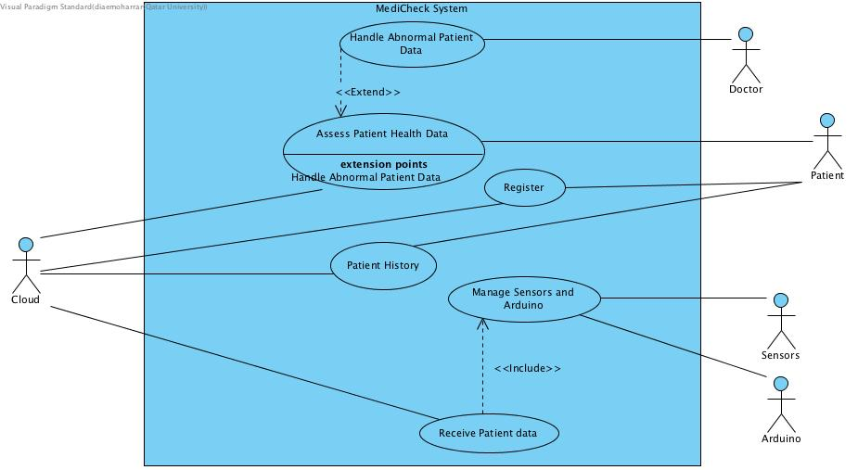

Figure 14 : Use-Case Diagram

## Non-functional requirements

The non-functional requirements of our system are mainly as follows:

1. Supporting a secure communication channels: The patients data are private and must be protected.
2. Supporting a large number of users: The system must be able to save and process large number of patient’s data.
3. Supporting real-time data exchange: The system’s users must be able to view their real time data in minimum time and low latency.
4. Having an easy useable system: The system must be easy to use for all users to reach user satisfaction and acceptance of the system.

## Design constraints

In this section, we discuss our project design constraint which are: technical constraints and practical constraints.

|  |  |
| --- | --- |
| Name | Description |
| Availability | The system must run 24x7x365, with overall availability 99% as the application will be available all the time and the sensor will be on when the patient is using it while the cloud maintains a backup of the patient’s data to prevent data loss and downtime. |
| Performance | Application performance must perform within a 15 seconds response time, to meet the requirements of the QoS. |
| Reliability | No data loss is allowed as all the data will be saved and back up while the mobile is connected to the internet. |
| Connectivity | While reading the data from the sensor the mobile application need to be connected to the internet.  Firebase database need to be connected all the time. |
| Efficiency | Time taken to transfer the patient data to the firebase cloud must be as low as possible.  Time taken to send notification for doctor in emergency case must be as low as possible. |
| Scalability | Our design will be handle more users in future and we can add more sensor and components to the device. |
| Usability of Sensors | For the device, it must be design carefully to simplify the using of these sensors on the target patient. |
| For the user interface, which is running on the mobile app must be user friendly and easy to use by any user. |
| Portability | The application can only work in android platform. |

Table 3. Technical Design constraints

|  |  |  |
| --- | --- | --- |
| Quality | Name | Description |
| Economic | Design Cost | Our system has multiple biomedical sensors that need to be precise in order to get precise data; where precise sensors cost higher prices than any other sensors. Moreover, the more functionalities integrated within the microcontroller, and the more the size becomes smaller the higher the price will get. Finally, regarding the software (cloud services and mobile app), in order to have a large database in cloud, we need to upgrade it, and this also will have extra cost. |
| Time | Development Schedule | For the security, we will only make a secure network between the mobile phone and the cloud, other networks, although they are secured, need advance security that can be achieved for further development of the project.  The system can communicate between the Arduino board and the mobile phone using Wi-Fi or Bluetooth only in our implementation, but it can also be connected using GPRS/4G if time allowed us.  Some hardware can be more flexible by using a wearable Arduino board, such as FLORA wearable Arduino board. But the student grant was limited and we could not have more alternatives being implemented for our system. |
| Environmental | User need | Patient should follow the instructions that is provide and be aware to place the sensors correctly. |
| Social | Government codes | All the data of patients are secured and only viewable by their doctor. |
| Ethical | Privacy | All the data of patients are private from the public. |
| Manufacturability | Transport | The sensors and Arduino are organized and packaged in one box. |

Table 4. Practical design constraints

## Design standards

**Wireless network:**

**WIFI (IEEE 802.11):** In 1997, the IEEE created the first WLAN standard which was only supporting a maximum network bandwidth of 2 Mbps that is too slow for most applications.

**802.11a:** supports bandwidth up to 54 Mbps and a regulated frequency spectrum around 5 GHz. Which means support fast speed but shorter-range signal that can be easily obstructed.

**802.11b:** supports bandwidth up to 11 Mbps and unregulated frequency around 2.4 GHz. Which means support good range and not easily obstructed, but low speed.

**802.11g:** supports bandwidth up to 54 Mbps, and frequency around 2.4 GHz for greater range. Which means fast speed and signal range is good and not easily can be obstructed. And it is compatible with 802.11b and can be used together.

**802.11n:** Standard is not yet finalized that support bandwidth up to 300Mbps, it is very fast and best signal range.

**802.11ac:** utilizes dual-band wireless technology and support connections on both the 2.4 GHz and 5 GHz Wi-Fi bands and bandwidth rated up to 1300 Mbps.

**2G-Second generation wireless:** It is a set of standards that are made, described and maintained by ITU- International Telecommunication Union- for mobile telecommunications. 2G offers services like voice calls, SMS and email, by using compression-decompression algorithm to compress and multiplex data.

**3G-Third generation wireless:** ITU defined 3G to facilitate growth, increase bandwidth and support more various applications. compared to 2G this generation does not only deliver voice but also circuit switched data at high speed up to 14.4Kbps. For mobile multimedia applications packet switched data with better spectral efficiency. it can offer data speeds as slow as 3.84 Mbit/sec. We have used 3G to connect the NodeMCU board to Firebase cloud.

**4G-Fourth generation wireless:** This cellular wireless generation replaces the 3G of broadband mobile communication. 4G is expected to provide mobile service users with bandwidth higher than 100 Mbps, to be enough to support high quality streaming multimedia content.

**Waterfall model:** a method development software process used to represent linear and sequential design process, called waterfall since the development process flowing downward, output of one phase is the input of the next phase, the sequential phases are system requirements, system and program design, coding, testing and maintenance.

## Professional Code of Ethics

* + - * to hold paramount the safety, health, and welfare of the public, to strive to comply with ethical design and sustainable development practices, and to disclose promptly factors that might endanger the public or the environment [20]; Use safe sensors that generates less electromagnetic waves that affects human body.
      * to improve the understanding by individuals and society of the capabilities and societal implications of conventional and emerging technologies, including intelligent systems [20]; creating awareness to encourage understanding of our device.
      * Respect the privacy of others [21]; patient data gathered should not be used for other purpose and should not be exposed to public.

## Assumptions

* 1. Patient should follow the instructions of using device to get accurate data.
  2. Patient must have the android phone to use the mobile application and receive the data from device.
  3. Wi-Fi should be available all the time to transfer the data.
  4. Doctor should be able to see the history data of the patient.
  5. Doctor must receive notification if there is any abnormality in the real-time data.
  6. Mobile application should be easy to use.

# **Proposed solution**

## Solution overview

Figure16 is showing the high-level architecture of our system. Which describe the detailed solutions and divided in to three major parts: Hardware side, communication (secured and non-secured) and Firebase cloud.

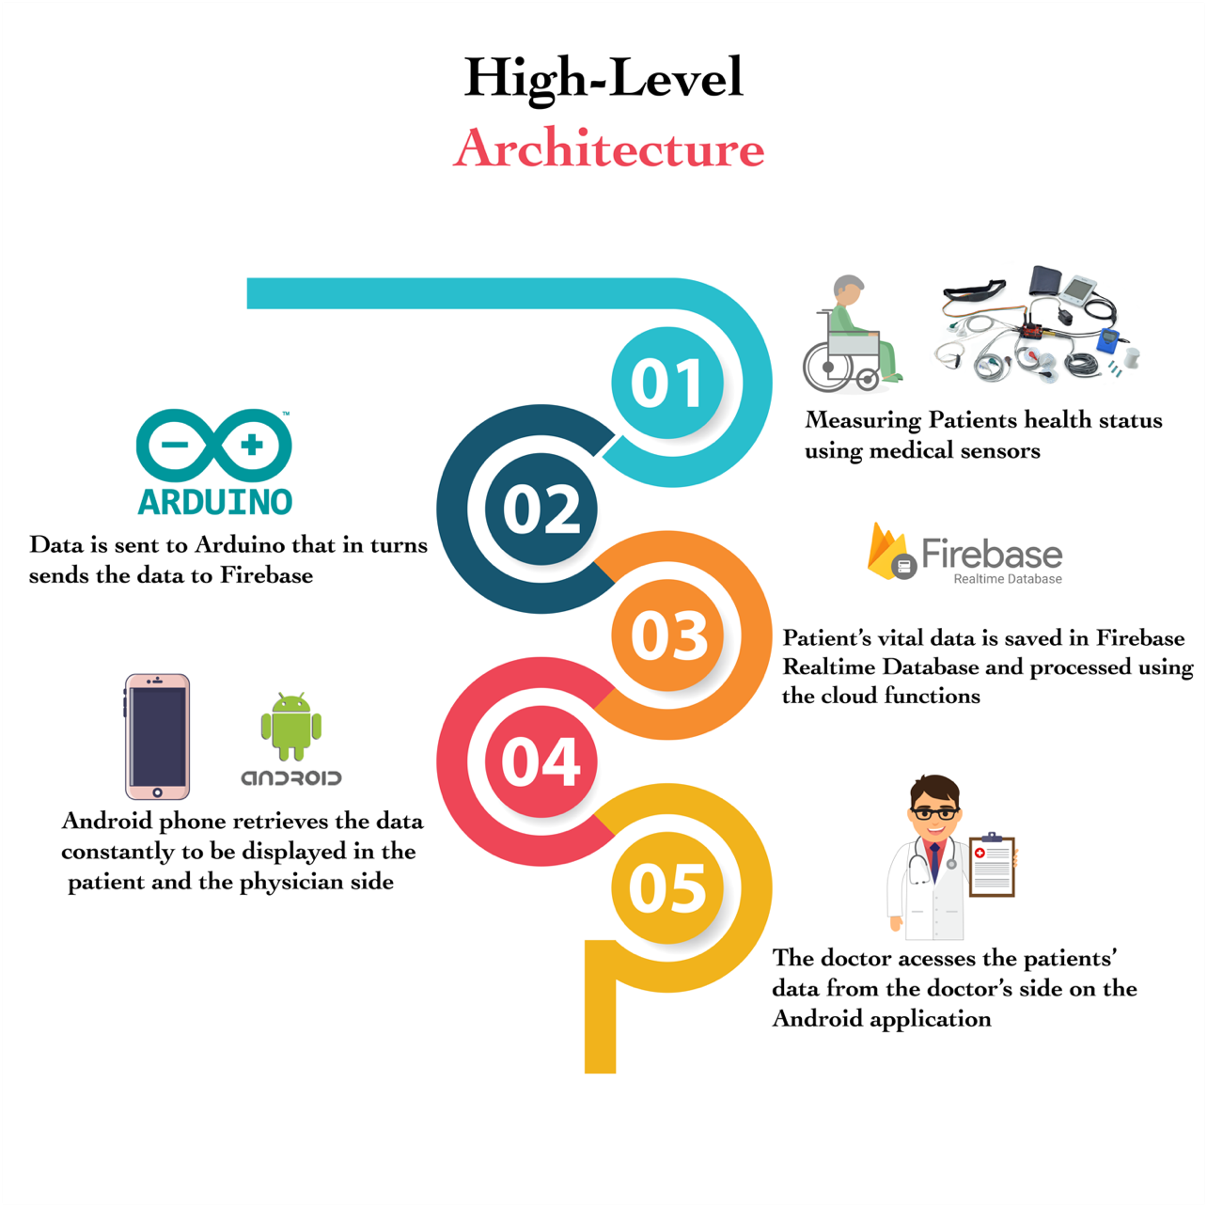

Figure 16: High Level Architecture

The solution design of our system is divided into two major parts: hardware solution and software solution.

The hardware solution will be consisting of E-Health sensors connected to the microcontroller, in this case using the Arduino, through My-signals hardware shield. Moreover, a Wi-Fi microcontroller will be used to transfer data from the Arduino to cloud database.

In the other hand, the software solution will be composed of a mobile app and cloud service. The mobile app will be build using Android Studio and cloud service for data manipulation and online database using Firebase.

The solution will include three sub-system designs:

* Sensors that will read patient’s data and transfer it through the Arduino
* Cloud and interfacing API’s.
* End-Device; a smartphone with UI application.

Our system design can be used by heart failure patients. The heart failure patients can use the device as a daily checkup to detect any abnormalities.

The system will start when the patient uses the device to take the measurements of body temperature, blood oxygen and blood pressure. Then, the device will send the measured data to the database in the cloud, and at the same time the data is received at the patient’s mobile app. Based on the real and historical data that is obtained from the cloud database, the doctor will be notified if there is any abnormality or irregularity. Indeed, the patient data is encrypted between mobile app and the cloud, where all the patient data will be stored in the cloud database. In the doctor side, the data will be fetch from the cloud and display on the mobile app.

The team approached a cardio specialist with many questions to assess the applicability of the system and to verify its functionalities. Dr. Waleed Khaled, who is a cardia specialist working in Hamad Hospital, has given the team great advices and discussed many scenarios related patients with hard failure occurring in the real situations. Based on the interview happened with Dr. Waleed Khaled some changes arise on our system’s solution. The outcome of the interview with the changes summarized as follows:

* The vital signs we are measuring are important parameters (Body temperature, SPO2, and Blood pressure) for heart failure patients, they need to use these sensors every day morning so they need periodic checkups. Additional important parameter is needed which is the patient’s weight. For heart failure patients, this parameter need to be tracking every day to avoid fluid in the lungs and legs.
* For data processing in the cloud, the system should compare the patient weight with the weight value taken the day before, and send notification to the doctor with all vital signs readings of that date if there is increase in the weight by 0.5Kg or more. If the weight decreases or stays the same, it means that patient is in normal state.
* The data processing of the other vital signs (Body temperature, SPO2, and Blood pressure) is just comparing the value with abnormality thresholding range, if any abnormality occurs send notification to the doctor with all vital signs readings of that date. Refer to the appendix for more information about the interview.

Finally, since our system is a mobile cloud computing-based application the issue of security arises as discussed in section 2.1.1. A secure application implements confidentiality, integrity, and authenticity. Communication of our E-health system is composed of: (1) communication between the E-health sensors and Arduino (direct connection, no security issue here), (2) from Arduino to firebase cloud, (3) from firebase cloud to mobile and (4) from firebase cloud to the doctor side (wireless connection).

Security measures need to be implemented at the application as well as network layer, since network level security measures alone are not enough for end-to-end security. In our IoT health application, data goes through following stages:

**Patient Mobile <=>Cell Base station1 <=>Centralized cloud => Cell Base station2 =>Doctor’s Mobile.**

Now, even though new cellular technologies provide network level encryption (such as 4G) from mobile device to the base station, data is decrypted at base station by cellular service providers and might go unencrypted from base-station to cloud through the core network (marked in RED above), which is a vulnerable link. Hence application level encryption is needed, such as additional encryption and authentication etc. [7]

The system will be developed in multiple stages; it is composed of requirements specification, system design, program design, coding, system testing and operation and maintenance consequently. Validations and verifications processes are done at each stage to be able to move forward to the next stage with the least errors. The best model to follow in such a case is the waterfall model, as shown in figure 8, that shows all the stages of system development. The advantage of using waterfall model is that the stages or phases do not overlap and are done one at a time, which gives a good view and better understanding before moving to the next stage. Moreover, it is simple and easy to understand and follow-up.

**Waterfall Model:**

Figure 15 : Waterfall diagram

* **Requirements specification:**

In this project, a cloud-based application is designed for heart failure patients who need daily checkup to identify their state whether they their state is stable or not. The system automatically sends notification to the doctor in case the patient’s data is showing any abnormalities. As discussed in the background of section 2.1.1 the system will consist of the hardware means that periodically measure some health aspects, such as: the body temperature, blood pressure, heart rate and oxygen saturation. The measured data will be sent to the cloud database and then received and displayed by the patient’s mobile app.

The system model we intend to develop in this study is progressing linearly through the following discrete, easily, understandable and explainable stages.

* **System Design Stage:**

The system design stage comes after analyzing the exact requirements of the system. A model solution is designed based on the system’s requirements specification.  In system design stage the hardware and software needed for our system are being identified. According to our project, the health-related hardware components used in the development are given in section 4.4.

* **Program Design Stage:**

After the system design stage, the program design is the third stage that the system will go through in the development process. This stage will have the high-level architecture to be done. After specifying the hardware and software from the previous stage, this stage will identify the integration between hardware and software, the type of communication channels to use, and which type of protocol to use (e.g. HTTP and TCP\IP protocols). As have been mentioned in section 2.1.3 the communication in our system between any two points will be WIFI, and data will be encrypted from mobile app to cloud and from cloud to the doctor side.

* **Coding Stage:**

In this stage, the code of our system will be written according to what we discussed above in system and program design section 4.1. The code will be implemented using Arduino IDE, Android Studio, and visual studio code. Android Studio will send the patient’s choice of a sensor to firebase cloud. In addition, we will need to encrypt the patient data before it’s transferred to the cloud to prevent unauthorized access. The doctor will be connected to the could platform by the app, mentioned earlier, in order to fetch real-time and historical data.

* **System Testing Stage:**

In this stage, several system components will be tested. We will need to test our code that is written to establish the end-to-end communication to make sure that it is coded correctly. If any bugs are found, some advanced validations will be done referring to the program design. E-health Sensors will also be tested to verify that the patient’s data are read correctly.  In addition, other testing methods will be used in testing the other aspects of the system, including connectivity, usability, and performance.

* **Operation and Maintenance Stage:**

Once the system testing stage is done, some problems may occur. In this stage, all the problems will be taken under consideration and will be fixed to meet our project requirements.

## High level architecture Discussion

*Below we discuss each step in Figure 16 in more details.*

* **Step 1-3: Hardware side:**

The hardware connections, as shown in figure (16-b), consist of four components: E-health sensors, Arduino UNO, Wi-Fi module and Firebase database. The hardware connection is described below in Table 5.

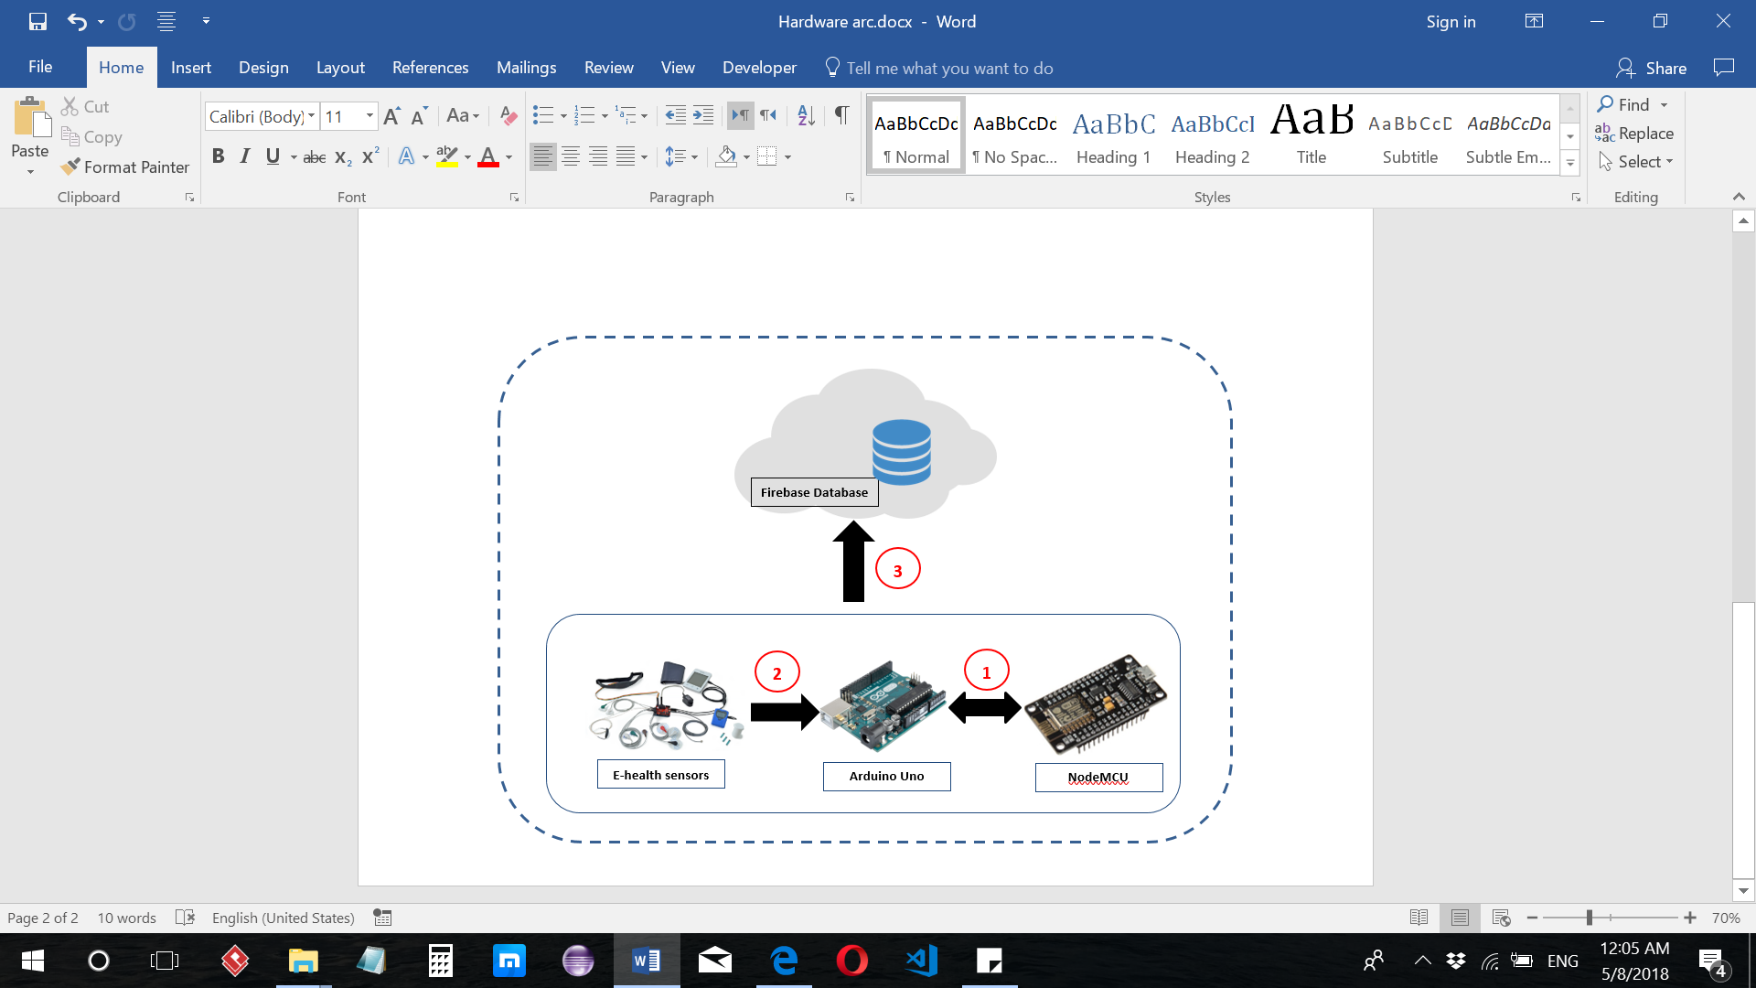

Figure 16-b: High Level Architecture

Figure 16-b : High Level Architecture

Figure 16-b1 : High Level Architecture

Figure 16- b: High Level Architecture

|  |  |
| --- | --- |
| Connection | Description of figure 16-b |
|  | To allow a communication between the Arduino Uno and the Firebase database, a Wi-Fi module should be provided. We used NodeMCU ESP8266 Wi-Fi microcontroller that will transfer the measured patient’s data to Android phone. A serial connection is used between Arduino Uno and NodeMCU. TX and RX of NodeMCU are connected to pin 2 and 3 in Arduino UNO respectively. |
|  | For the patient to use the E-health sensors an additional E-health shield (My-signals board) is needed. My-signals board is a board that supports more than 8 sensors, this board must be placed over the Arduino Uno. The sensors will be placed on the board allowing the Arduino collects data. |
|  | This channel will use WIFI connection to Send measured data from Arduino Uno to the cloud. The patient’s data will be encapsulated by TCP protocol to be delivered to cloud. In this communication channel, since we are discussing the security issue the WIFI is considered more secure [34]. WIFI security standards have been raised up with insertion of new versions, like Wireless Equivalent Privacy (WEP) and Wi-Fi Protected Access (WPA) which utilize [wireless encryption keys](https://www.lifewire.com/what-is-a-wireless-key-818351), and long sequences of [hexadecimal numbers](https://www.lifewire.com/working-with-binary-and-hexadecimal-numbers-816247). An Additional application security will be needed to protect the patient private data. More discussion about this channel’s security will be provided in next step 3-5. |

Table 5. Hardware connections description

* **Step 3-5: Secured communication:**

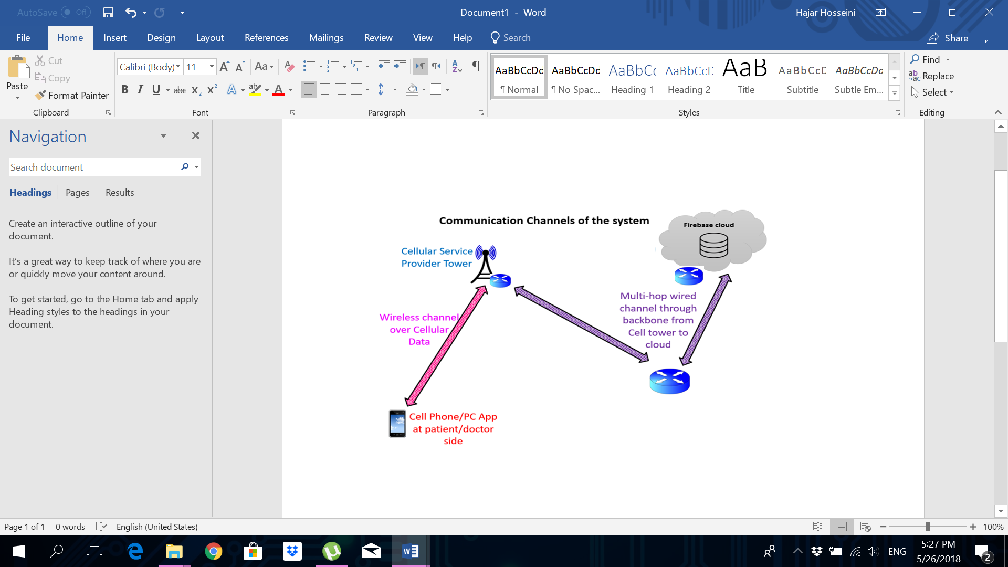

Figure 16- c : High Level Architecture

These channels are the most critical communication channels which needs to be secured. In the communication channel between the mobile and cloud (3 to 4) in figure 16 and communication channel between cloud and doctor side (3 to 5) in figure 16 we will implement security mechanisms to secure them (data and commands) over the Internet. Multiple encryption algorithms/mechanisms were discussed earlier in section 2.1.3 of this report, where we will use RSA asymmetric encryption algorithm to protect the patient data from unauthorized access. The reason is, it is the most widely used encryption algorithm, which has proven to be the most difficult to crack down. Also, it does not need to communicate the encryption key, which is the main hurdle in symmetric encryption algorithms.

Remark: Multi-hop wireless network is a network that has one or more intermediate nodes that pass packets through wireless links.

* **Step 3: Firebase cloud:**

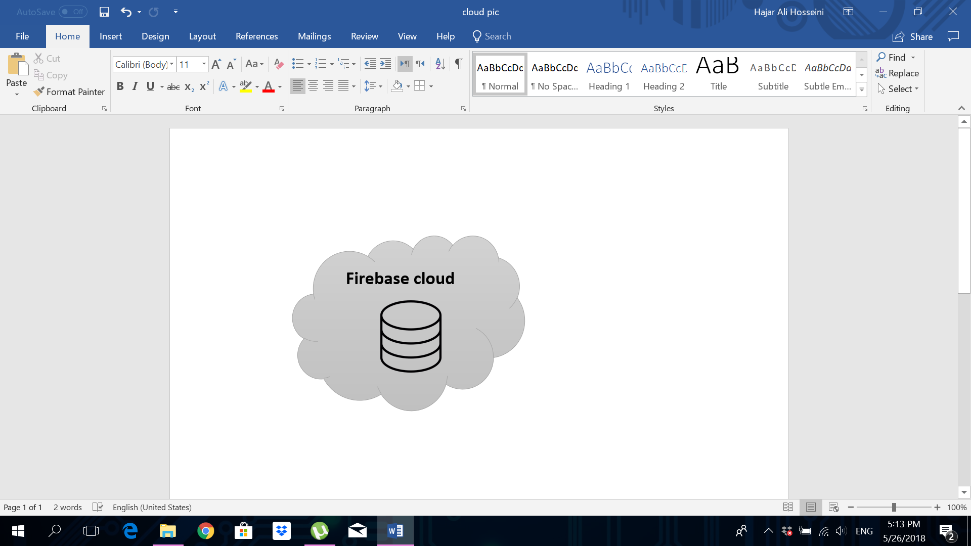

Figure 16- d :High Level Architecture

The data in the firebase database will be decrypted before storing it. Firebase database provides a full set of tools to manage the security in your app. The provided tools make user authentication, user permissions and input validation easier to manage.

## Hardware/software used

## 4.3.1 Hardware

In this section, we discuss various hardware that are related to our project and clarify specification of each component.

**4.3.1.1 Controllers:**

* **Arduino:**

Arduino is an open-source electronic platform that is based on easy usable hardware and software. The Arduino board is capable of reading inputs from sensors, as an example and output the result to the system or to do simple output of turning ON a light or any reaction similar to that. There are two ways to do so; either using an Arduino programming language that is based on wiring, or using the Arduino software-IDE that is based on processing. There are many advantages of using Arduino:

* It is inexpensive compared to other microcontrollers
* It is a cross-platform that works on windows, Linux OS, and others
* It has a simple and clear programming environment that is easy to use for beginners
* It is open source and an extensible software and hardware; which language can be expanded through C++ libraries and an AVR-C code can be added directly into the Arduino program.
* Experienced designers can make their own module, extending and improving it
* Moreover, the Arduino board is powered via the USB connection which takes 5V input and has 14 digital input/output pins, 6 analog inputs, a 16 MHz ceramic resonator, a USB connection, a power jack, an ICSP header, and a reset button.
* ***Raspberry Pi:***

Raspberry pi is a credit-card sized purpose computer that plugs into a computer or TV and uses a standard keyboard and mouse. It has the ability to interact with outside world, run multiple programs at a time and uses python or Scratch programming languages. Also, Raspberry pi is capable of doing everything you’d expect a desktop computer to do, from browsing the internet and playing high-definition video, to making spreadsheets, word-processing, and playing games. Compared to Arduino, Raspberry Pi is much expensive but the PMW has a limited frequency, and does not have ADC.

* ***NodeMCU:***

NodeMCU is an open source development board. It is used [ESP8266 -12E Wi-Fi module](http://store.fut-electronics.com/products/wifi-esp8266-12-serial-ttl-module-esp-12). The features of NodeMCU combine features of microcontroller plus Wi-Fi. It can be programmed by using [LUA programming language](http://http/www.lua.org/about.html) or Arduino IDE.  [3]

**4.3.1.2 Shields:**

A shield is nothing but a specialized hardware aimed to perform some specific tasks, mostly other than computation, which is the main task of the microcontrollers. Here, we will discuss various shields available to aid the microcontrollers to perform various activities such as providing connectivity to the sensors, providing Wi-Fi or Bluetooth connectivity, etc.

* ***MySignals e-health platform:***

E-health sensor platform is designed by Cooking Hacks Company. This platform supports 11 sensors such as Pulse and Oxygen in Blood Sensor (SPO2), [Body Temperature Sensor](https://www.generationrobots.com/en/402175-body-temperature-sensor-for-e-health-platform.html) , ECG, Blood pressure. We need to use this platform to connect the sensors.

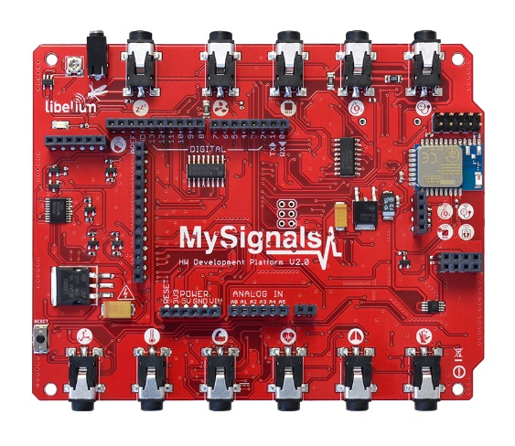

*Figure 1: MySignals e-health platform*

**4.3.2.1Sensors:**

Sensors are electrical components that read, detect and respond according to the input data or changes in the physical environment. The output of these sensors is converted to human readable data and can be stored in a database for further investigation or future comparison or reference.

* ***Pulse Sensor:***

Pulse Sensor is a plug and play heart rate data sensor that can be used for Arduino. Its open source sample code for visualizing heart rate data is available as a reference. It has sips power in just 4mA current draw at 5V, which makes it suitable for our project as we will be developing a mobile application. This pulse sensor includes two ways of usage, either using the clip on a finger or the earlobe to read the heart rate of the user. It also comes with a 24-inch color coded cable with 3 pin male connectors, which must be connected to an Arduino board in order to collect the user’s data.   
In order to connect the sensor to Arduino, the red wire is connected to the Vcc +V, the black wire to the GND, and the purple wire to the Analog pin 0.

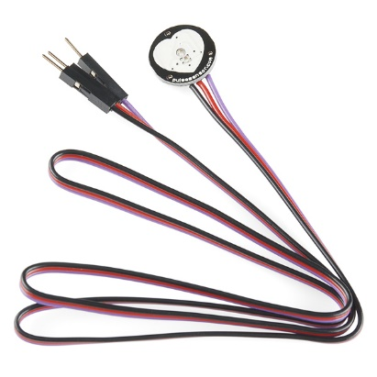

Figure 2: Heart-Rate sensor

* ***LM35 temperature sensor:***

Body temperature is the most important parameter to be measured in human body, before any other parameter, to indicate the person state of health. Therefore, this sensor is used to measure the body temperature accurately than with a thermistor, as well as it is suitable for remote applications. LM35 temperature sensor is available and has a low cost that can be directly connected to Arduino. The output voltage is linearly proportional to the Celsius temperature.

LM35 sensor output is calibrated directly in Celsius and the source can current up to 10 mA. This sensor is made up of 3 pins: first pin is reserved for Vcc, second pin is reserved for the output and the last pin is reserved for GND. The supply voltage is from 4V to 20V. The scale factor is + 10mV/°C, which means if the temperature is 38°C the output line read 0.380 V. Finally, the output impedance almost 0.5 ohm.

The LM35 is rated to operate over a −55° to +150°C temperature range. The maximum sensor accuracy is +/- 0.5 C. [4]

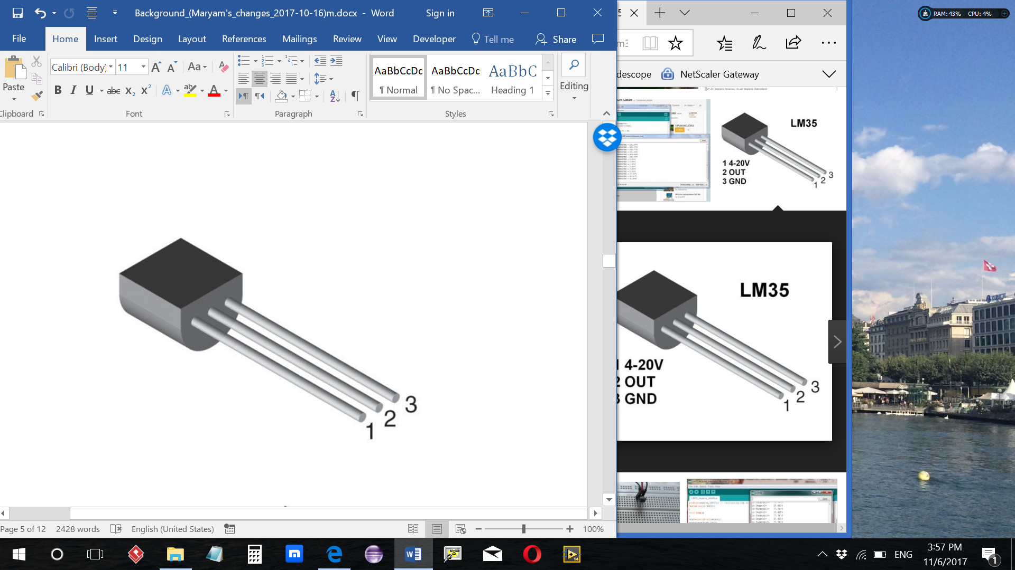

Figure 3: LM35 sensor

* ***Pulse and Oxygen in Blood Sensor (SPO2) for E-Health Platform:***

Pulse and Oxygen in Blood Sensor (also called oxygen saturation) is used for sensing the amount of oxygen that is dissolved in blood. To use this sensor, it must be connected to e-health shield that is compatible with [Arduino](https://www.generationrobots.com/en/401278-arduino-nano-board-30.html). The bloodstream is affected by the concentration of Oxygenated hemoglobin (HbO2) and deoxygenated hemoglobin (Hb). SPO2 sensor outputs are two different light wavelengths: one in 660 nm that is red light spectra and the other 940 nm that is infrared light spectra. These two wavelengths are used to measure the actual difference and the absorption coefficients of HbO2 and Hb. The acceptable normal ranges for patients are from 95 to 99 percent, and those with a hypoxic drive problem would expect values to be between 88 to 94 percent. Values of 100 percent can indicate carbon monoxide poisoning. [5]

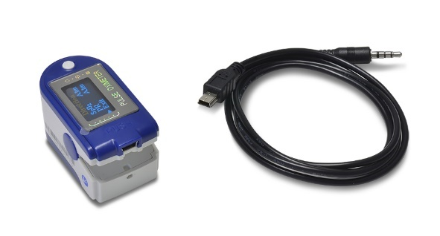

Figure 4: SPO2 sensor

* ***Body Temperature Sensor for E-Health Platform:***

E-heath platform support more than 8 sensors, one of the most useful sensors is body temperature sensor. It starts its measurements from 37.0°C (98.6°F). As the error of the measurement, which is measured in voltage, is less, the more accurate temperature readings we can get.

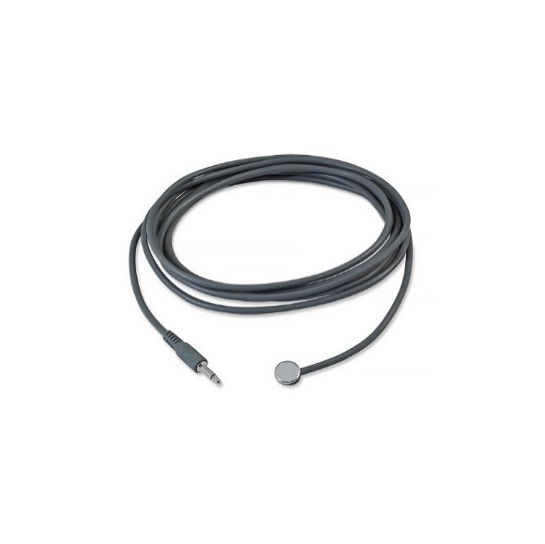

Figure 5: Body Temperature sensor

* ***Airflow Sensor (Breathing) for e-Health Platform:***

Airflow sensor is used to sense the patient breathing rate. It is one of the sensor used with [e-Health Sensor Shield](http://www.cooking-hacks.com/index.php/ehealth-sensor-shield-biometric-medical-arduino-raspberry-pi.html). The nasal airflow sensor is a device used to monitor airflow rate of a patient in need of respiratory help. This device consists of a flexible thread that fits behind the ears, and a set of two prongs that are placed in the nostrils. The patient’s breathing rate is measured by these prongs. [5]

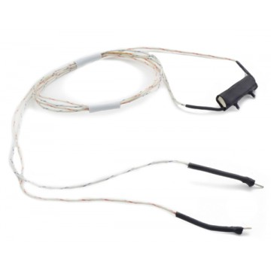

Figure 6: Breathing sensor

* ***The Electrocardiogram Sensor (ECG) for e-Health Platform:***

Electrocardiogram sensor can detect several heart measurements of the patient; like the orientation of the heart and hypertrophy of the heart muscle. E-Health ECG sensor consists of three leads: red (positive), black (negative) and neutral (white), which are connected to the electrodes in the e-health board. This sensor returns an analogic value in volts (0 – 5) to represent the ECG wave form. [5]

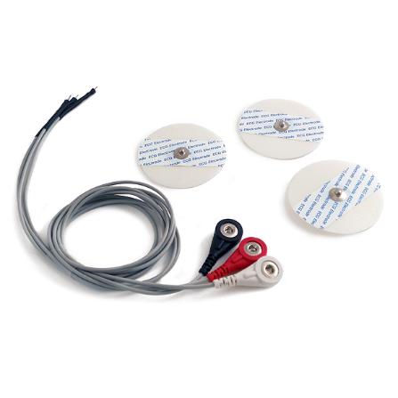

Figure 7: ECG sensor

## 4.3.2 Software

* **Cloud platforms:**
* ***Amazon Web Server (AWS):***

Amazon Web Services (AWS) is a secure [cloud](https://aws.amazon.com/what-is-cloud-computing/) services platform, that offers to compute power, database storage, content delivery and other functionalities to help businesses scale and growth [6]. AWS is available for free accounts that include 12 months of free trial access with virtual services and scalable storage in the cloud. It also provides libraries, sample codes, and tutorials. The libraries and resources are available in many languages such as Java and C++. For the Documentations, AWS provides full documentation for useful information about the services, from introductions to advanced features. Another great feature of the discussion forums, AWS provides 24 h access to technical support and guidance resources.

* ***Azure cloud server:***

Azure is a complete set of cloud services that is used by IT professionals and developers to build, manage, and deploy applications through their worldwide network of datacenters. Azure gives the ability to create powerful Web, mobile or API apps without having an account. It provides free accounts for 12 months of free access to its popular products. The account provides Windows and Linux virtual machines with on-demand capacity in seconds that has 64 GB X 2 secured disk storage, LRS File Storage, Azure SQL Database, and Transfer data inbound and outbound through their robust network of worldwide data centers. Moreover, Azure provides Documentation for quick starts, samples, and tutorials for all the services provided, they also provide support forums that can answer all the questions in a fast manner. Finally, Azure has its own IoT suite that offers a broad range of capabilities such as collecting data from devices, analyzing data streams in-motion, store and querying large data sets, visualizing both real-time and historical data, integrating with back-office systems and managing the devices. [7]

* ***Cloudino:***

Cloudino is an internet of things platform that has many services web IDE (based on Arduino IDE), Cloud Arduino Programming, Cloud Storage, Rule Manager, Message Manager, and Device Console. Cloudino also provides special services to connect to the cloud in an easy and transparent way. It has WIFI cloud connector, which is not Arduino shield, but another processor that works in parallel dedicated only for the network layer including the IoT protocols, freeing the Arduino dedicated for connection to the sensor and allowing reprogramming Arduino through WIFI or Cloud. It is based on low cost ESP8266, and has firmware and a special Arduino library that can be used with Arduino. Cloudino supports JavaScript programming language and has many afforded examples and full documentation to help the user. Cloudino is available for free accounts with all privileges. [8]

* **Mobile Application Development Platforms:**
* ***Android Studio:***

Android is a free open source platform for app development. It has a variety of built-in functionalities to build a high functioning app with the ability to design a user-friendly app. It supports instant running, as code is modified or changed, either directly in a connected device or using an emulator.  
Android studio is built on IntelliJ that allows it to have advanced capabilities of code completion, refactoring and code analysis.

* ***Mobile Roadie:***

Mobile Roadie is a platform that unites app creation and mobile marketing.   
It is not free nor an open source platform. Apps can be built using drag-and-drop feature, using one of the templates provided by its developers according to the required category.

* **Web Application Development Platforms:**
* ***AWS Elastic Beanstalk:***

Elastic Beanstalk is a Platform as a Service (PaaS) from Amazon Web Services that allows users to create applications and push them to a definable set of AWS services, it is an easy to use service for deploying and scaling web as it help the developer to focus on writing code rather than spending time managing and configuring servers, databases, load balancers, firewalls, and networks. [9] Moreover, it has auto scaling setting which help to scales the application up and down automatically, it is enhancing application security by enabling HTTPS protocol on the load balancer.

* ***Azure Web App:***

Azure Web App is a Platform as a Service(PaaS) service for hosting web applications, REST APIs, and mobile back ends. It can be developed using .NET, .NET Core, Java, Ruby, Node.js, PHP, or Python. It can run and scale apps with ease on Windows or Linux. [10]

## 4.3.3 Security Means and Impacts

Our system is based on mobile cloud computing (MCC), the client-server architecture type, where the mobile is considered to be the client and the cloud is the server side. The security issues in the mobile-to-cloud is divided into three things: security issues of the mobile, security issues of the cloud and the security issues of the communication channel between the mobile and cloud.

our system will involve carrying patient’s data, which is private information. Such data must be hidden from everyone except the doctor. Such data can be attacked in two ways, by outside cloud attacker and inside cloud attacker. The inside cloud attacker is difficult to be identified, to resolve this issue the data can be protected and encrypted before transmission to cloud either for data stored in cloud or while moving to another device. As a result, we discuss the security issues of the WIFI, as it is one common used way of providing communication in many systems, and why we need to secure this channel. We will also discuss how securing the mobile-to-cloud channel can be done.

WIFI is known to be a secured method of providing wireless communication as mentioned in [11]. A WIFI network using WPA2 provides both secured and private communication as data travels across the network. In order to have maximum security, the devices connected through the network should have the latest security techniques, which is WIFI Protected Access 2 (WPA2). The WIFI security should be enabled where, by default, it is disabled in the devices for easier setup of the network. These default settings should be changed as soon as you set up your network to enable security. After that, when the data travels beyond your secured network, there is no guarantee that the data will stay secured. Therefore, adding another security layer will ensure the privacy and security of the data in all cases, whether the WIFI device is providing WPA2 or not, or the security in the devices is enabled or not. This will guarantee a secured data beyond the user network.

Below as shown in (Table 1) we discuss different types of encryption algorithms that can be implemented to secure mobile-cloud communication channel. This is the most critical communication channel which needs to be secured. We now discuss important cryptography algorithms and choose the suitable algorithm for the needs of our application. Table 1 shows a brief comparison that involved the key aspects for the important cryptography algorithms we investigated that could be used in our solution to secure the channel of communication between the mobile device and the cloud. The key aspects used in this comparison are:

* Block Size: the number of bits that can be transformed by the block cipher.
* Stream Cipher: method of encryption that use a fixed length key to produce stream bits.
* Key Size: the number of bits in the key
* Symmetric Encryption: encrypt and decrypt using the same key.
* Asymmetric Encryption: encrypt and decrypt using different key.
* Rounds: the number of rotations to create a function.

|  |  |  |  |  |  |  |  |
| --- | --- | --- | --- | --- | --- | --- | --- |
| Sr. No | Algorithm | Block  Size | Stream Cipher | Key Size | Symmetric Encryption | Asymmetric Encryption | Rounds |
| 1 | **DES**: (Data Encryption Standard) | 64 bits | Not | 56 bits | √ | Not | 16 |
| 2 | **3DES:** (Triple DES) | 64 bits for each block | Not | 168 bits, But the effective key size is 112-bits | √ | Not | 16 |
| 3 | **AES:** (Advanced Encryption Standard))Rijndael cipher ( | encrypts blocks of 128 bits | Not | 128, 192, or 256-bit key | √ | Not | 10, 12, 14 |
| 4 | **RSA** | Depends on key size | Not | 1,024 to 4,096 bits | Not | √ | 1 |

*Table 1. Cryptography Algorithms*

**4.3.4 Hardware and Software Used:**

|  |  |
| --- | --- |
| Hardware | |
| Arduino Uno | The Arduino Uno is an open-source electronic platform. This board used to read inputs data from sensors and send this measured patient data to the firebase cloud with the help of ESP8266 Development Board. This microcontroller programmed using Arduino [integrated development environment](https://en.wikipedia.org/wiki/Integrated_development_environment) (IDE). |
| NodeMCU (ESP8266 Development  Board) | The NodeMCU is an open source development board. It is used [ESP8266 Wi-Fi module](http://store.fut-electronics.com/products/wifi-esp8266-12-serial-ttl-module-esp-12) in order to get access to the Wi-Fi network. This board is connected serially with Arduino Uno to allow the measured patient data to be transferred to the cloud. In addition, the keypad and LCD display are connected to the digital line pins of this board. NodeMCU programmed using Arduino IDE. |
| Smart phone | Android operating-system based phone is used in patient side to be able to download the Android App to control the sensors and to receive his data from the cloud. In addition, using android phone is better than using iOS phone, because android is an open source system, which means that anyone can easily build up an application. |
| Mysignals e-health platform | MySignals e-health platform is a board that supports more than 8 sensors. In this project, this board is used to connect body temperature sensor, Blood pressure sensor, SPO2 sensor. In order to programmed MySignals board an Arduino Uno board is needed. MySignals board with an Arduino Uno can be powered by PC or with 12 V power supply. |
| Body Temperature Sensor for E-Health Platform | The temperature sensor measures the human body temperature. The sensor can work with direct power supply and is connected to MySignals board to the specific temperature pin. Moreover, the range measurement starts from 0 to 50°C. The sensor takes time to reach the correct body temperature. |
| SPO2 Sensor for E-Health Platform | SPO2 is used to measure the amount of oxygen that is dissolved in blood.  Acceptable normal ranges for patients are from 95% to 99%. [3] |
| Blood pressure for E-Health Platform | Blood pressure measurement range 0-300 mmHg.  Ideal and health blood pressure reading:(90/60) <BP< (120/80) |
| 4x4 Matrix Membrane Keypad | The keypad is interface component for microcontroller with 16-button, combines numbers and letters. The component connected to the digital line pins in the NodeMCU. Keypad allow the system to distinguish between users’ data. |
| LCD display | The LCD display is an electronic screen module. it is basic and is very easily programable module. LCD is operate at 5 volt and is connected to NodeMCU in order to display the user entered id. |

Table 6. Hardware Components

|  |  |
| --- | --- |
| Software | |
| Firebase | Firebase is a Backend-as-a-Service — BaaS. in abroad sense it is a mobile and web application development platform. Firebase frees developers to focus crafting fantastic user experiences. Firebase works as a server, an API and a data store, all written so generically that you can be modified to suit most needs. |
| Android Studio v.3 | Android is a free open source platform for app development. It has a variety of built-in functionalities to build a high functioning app with the ability to design a user-friendly app.  We will be using Android Studio to build our mobile application that will receive the data directly from the Arduino board and sends it to the cloud server. |
| Arduino software 1.6.12 | The Arduino integrated development environment (IDE), that is a [cross-platform](https://en.wikipedia.org/wiki/Cross-platform) implementation written in the programming language [Java](https://en.wikipedia.org/wiki/Java_(programming_language)).  In our project, this software will be used to setup a program for reading the data from the sensors then sending the data to the mobile application either through a Wi-Fi shield or Bluetooth. |
| Visual Studio | Visual studio code is a lightweight and powerful source code editor that runs on the desktop and is available for Windows, MacOS and Linux. It has a built-in support for JavaScript, TypeScript and Node.Js. We have used visual studio code to write and deploy the Firebase cloud functions that has been written in JavaScript. |

Table 7. Software Components

## Hardware design

This section contains all relevant discussions and connection diagrams related to the hardware design of our system. The hardware components are carefully selected and optimized to provide the best performance for the system. The following subsections briefly cover the hardware components used in the system developed in this project, and the reasons for being used.

### **Hardware Components**

* **Arduino Uno**

The main reason of choosing Arduino microcontroller since our sensors board MySignals is compatible only with Arduino Uno.

* **NodeMCU ESP8266**

The goal of choosing this board is to deliver the sensed patient data to the firebase database. To program this board, the ESP8266WiFi.h library is needed, which cannot be used with another board like, Arduino Uno.

* **Android Devices**

The system mobile application was built using Android studio that runs on Android device. The main reason behind choosing this device is that it’s platform for application development is free and open source.

### **Circuit Diagram**

This subsection shows how the hardware components have been connected. The figure 17 shows the wiring diagram of the system.

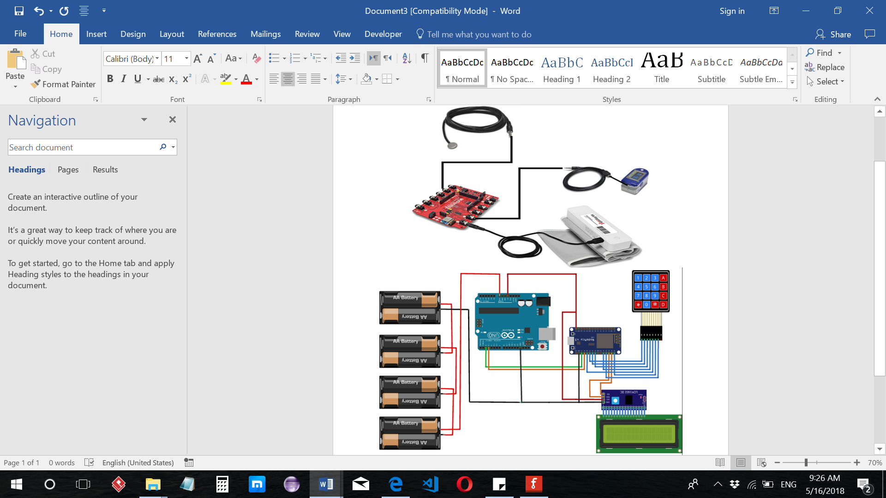

Figure 17 : System Circuit Diagram

The Body temperature, SPO2, and Blood pressure sensors are connected to its specific jack connector in MySignals board. The MySignals board is placed over Arduino Uno. The Arduino Uno is connected serially with NodeMCU ESP8266, so pin 2 and pin3 in Arduino UNO are connected to TX and RX of the NodeMCU ESP8266 respectively. Also, the LCD display and the keypad are connected to the NodeMCU ESP8266. Pin SDA and pin SCL of the LCD display are connected to pin D2 and pin D1 of the NodeMCU ESP8266 respectively. While, pin 1 to pin 7 of the keypad are connected to D3, D0, D8, D4-D8 of the NodeMCU ESP8266 respectively. In addition, the NodeMCU ESP8266 and LCD display they get input voltage (Vin) from pin 5V of the Arduino Uno. the Arduino Uno are powered with 12V either from battery or Arduino power supply adapter.

### **Hardware Cost**

|  |  |  |
| --- | --- | --- |
| Component | Quantity | Price |
| MySignals HW (eHealth Development Shield ) | **1** | **1,760 QR** |
| Body Temperature sensor | **1** | **320 QR** |
| Blood Pressure Sensor | **1** | **896 QR** |
| Pulse Oxygen in Blood Sensor | **1** | **624 QR** |
| ECG Sensor | **1** | **225 QR** |
| NodeMCU ESP8266 | **1** | **32 QR** |
| Keypad | **1** | **10 QR** |
| Total price = 3867 QR | | |

Table 8. Hardware Cost

## Software design

### **Android Studio Application Development**

In this section, more software development is mentioned. Firstly, a summary of the application is described. Secondly, the application flowchart is added. Finally, Table 9 contains the important libraries imported and used in Android studio is illustrated.

The application starts, once downloaded for the first time, with a welcome slider telling the new user some of the main features of the application. This welcome slider is shown only once when downloaded then it is disabled. Afterwards, a login page is displayed asking the user to login if he/she is an existing user, otherwise sign-up by choosing if the user is a patient or a doctor.

If the user is a patient, once signed-up, a unique device Id is generated for the user in order to be used to identify the user for sensor readings. This Id is displayed on the patient homepage as a reference for the user. The users’ authentication Id is taken in order to create a child node under the ‘users’ parent node in the Firebase database. And a token (an Id used to send and receive notifications from Firebase) is created for the mobile where the user first signed-up in.

Both the ‘Read your vital data’ button and ‘History’ button obtain the device Id from the users ‘id’ child node in the database in order to use it as a reference to read or write data from and to the ‘readings1’ node in the database. This node contains all the readings of every user. Each user is identified from the others by the device Id generated when the user signed-up.   
If the user is a doctor, a listView is inflated in the main screen of the doctor’s side application, looping through all the users existing under the ‘users’ parent node in Firebase database. Each item in the listView contains two important parameters, the user’s device Id followed by the user name. The user’s device Id is chosen to be displayed rather than the user’s authentication Id for two reasons:

* Because the user’s device Id is only 6 digits long and can be read easily. Where the user’s authentication Id is +15 digits long and not suitable to be displayed on small screen devices.
* The user’s device id is used to extract the user’s vital data under the ‘readings1’ parent node in Firebase database.

Once the doctor selects a specific user, the user’s device Id and name are sent as extra entries with the Intent calling SingleUserAcltivity.class to display the user’s latest vital data, last date and time updated, and two other buttons, ‘User History’ and ‘Back’ button.

The flow chart below, Figure 18, illustrates the application logic.



Figure 18 : Application Logic Flow Chart

|  |  |
| --- | --- |
| Firebase.database | Mostly used for realtime database. The data is synchronized automatically from and to Firebase Database. |
| Firebase.database.FirebaseDatabase | Is the entry point for accessing a Firebase Database. |
| Firebase.database.DatabaseReference | A Firebase reference that represents a particular location (child node) in the system Database and can be used for reading or writing data to that Database location. |
| Firebase.database.ValueEventListener | Is used to receive events about data changes at a child node location. |
| Firebase.auth | Firebase authentication library that permits receiving the current connected user on the single device in order to use Firebase database. |
| Firebase.iid.FirebaseInstanceId | Provides a unique identifier for each app instance and a mechanism to authenticate and authorize actions, especially sending a message. |
| firebase.messaging.FirebaseMessagingService | Base class for receiving messages from Firebase Cloud Messaging. |
| android.app.NotificationManager | Class to notify the user of events that happen. It is used to tell the user that something has happened in the background. |

Table 9. Android Studio Important Libraries Used

### **Arduino IDE**

#### **NodeMUC ESP8266**

The program starts by WIFI SSID and password configuration and connecting to the network. Then, a connection to the Firebase cloud is established as well as a Serial connection, which will facilitate ESP8266 NodeMCU communication with Arduino Uno. After that, the user must enter the Arduino ID that will be generated from the app side. The program first check if that ID exist, then a specific path to firebase database will be generated for that user. ESP8266 will send the option to Arduino Uno when the patient selects a sensor option from the list of four sensors (options 1-4). The sensor number selected by the patient will enable a specific sensor. If number 1 is received then ESP8266 will send that choice to the Arduino Uno and enable the temperature sensor, which will read back the result of that sensor and send it to firebase database. The patients can view the readings from their app. The same procedure will be followed for the other sensors. Number 2 will enable SPO2 sensor and number 4 for blood pressure sensor. Following is the flowchart of ESP8266 NodeMCU program.



Figure 19 : ESP8266 NodeMCU Flowchart

#### **Arduino Uno**

The program starts with the setups, the serial connection and my-signals hardware shield connection setups. The main program loop starts with reading the user choice from the serial connection. Once the program reads the selected sensor number it then enables the specified sensor. If it receives number 1 then temperature sensor will be enabled, and the measurement will be sent to ESP8266 and then go back to the beginning of the loop to check if there is another coming choice. The same procedures will apply to SPO2 and blood pressure sensors if number 2 and 4 received respectively. Following is the flowchart of Arduino Uno program.



Figure 20 : Arduino Uno Flowchart

## Structural model

|  |  |
| --- | --- |
| **Use Case Name** | **Use case Brief Description** |
| Register | User/doctor data is saved in Firebase Database |
| Manage Sensors and Arduino | Sensors are enabled or disabled <<include>> (Receive Patient data) |
| Receive Patient Data | Data is retrieved from sensors and saved in Firebase Database |
| Assess Patient Health Data | Patient Data is analyzed <<extend>> (Handle Abnormal Patient Data) |
| Handle Abnormal Patient Data | Notification is sent to doctor including latest readings and patient information, and to patient with warning message |
| Patient History | Data is retrieved from Firebase Database and is displayed to the user |

Table 10. Use cases brief description

## Database design

Since Firebase allows only one database per project, MediCheck system has only one database divided into sub databases, or parent nodes, which contain all the data of our application’s users and readings.   
The databases are as follows: Doctors database, Readings database and Users database. A brief description of each database is written bellow.

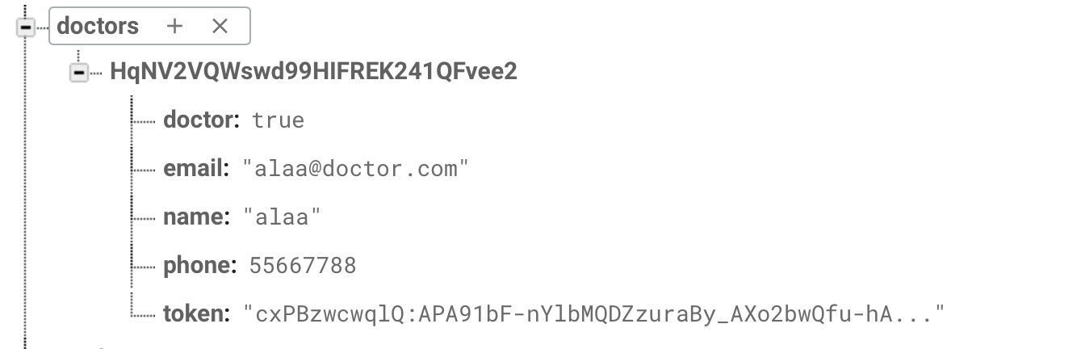

Figure 21 : doctors DB

As shown in Figure 21, the doctors database node has a child node, which is a doctor registered in the system. Each doctor child node is identified by the authentication ID of the doctor. Under each doctor’s node, all the information of the doctor are included and saved.

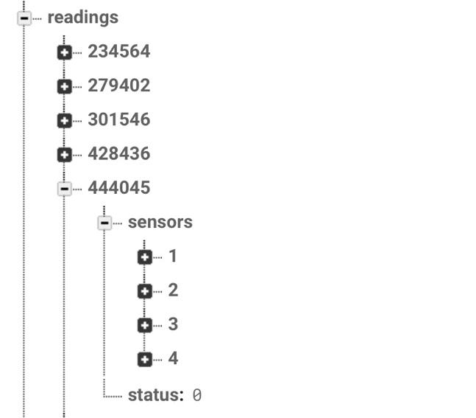

Figure 22 : Sensors Readings DB

The readings database contains each users device Id. Each user has a unique device Id which is connected to the sensors. Each child node in the readings database has two child; sensors, which is a node that contains subnodes, and status that gives a signal (as a number) to enable a specific sensor. Under the sensors node are four other nodes, 1, 2, 3, and 4 that contain the data of the temperature, SPO2, weight and BP sensors respectively (see Figure 22).

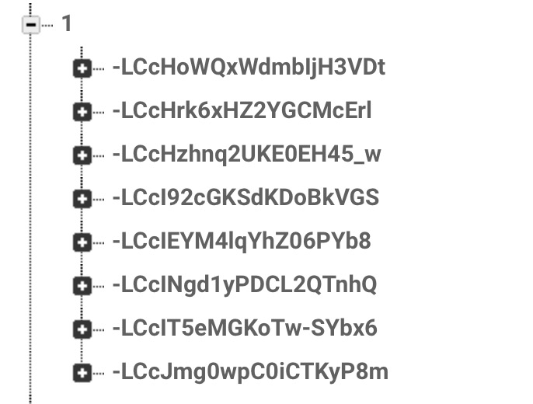

Figure 23 : Temperature sensor node (node ’1’) and the child nodes under

Each sensor node has child nodes that are the different readings of the same sensor. Each reading has a unique id that identifies it. Figure 23 shows the child nodes of the temperature sensor node of a specific user (node 1).

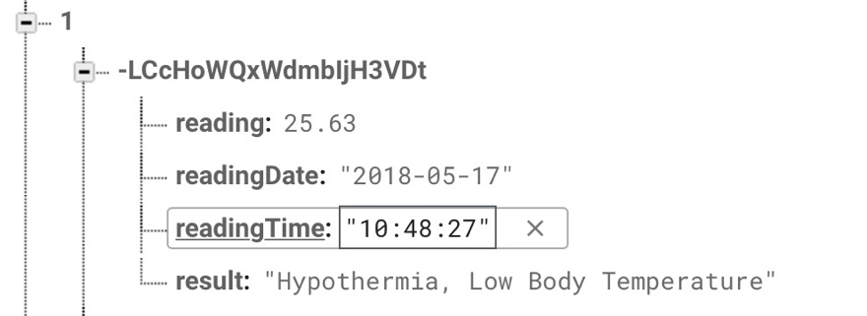

Figure 24 : Temperature sensor single reading information

As shown in Figure 24, each child node under the temperature sensor node has the reading information, date, time and the result of the reading based on some analysis done in the cloud functions.

The ‘users’ database, contains all the users registered to the system. Each sub-node under the ‘users’ database is identified by the authentication Id of the users. Figure 25 illustrates the ‘users’ database and the registered users sub nodes.

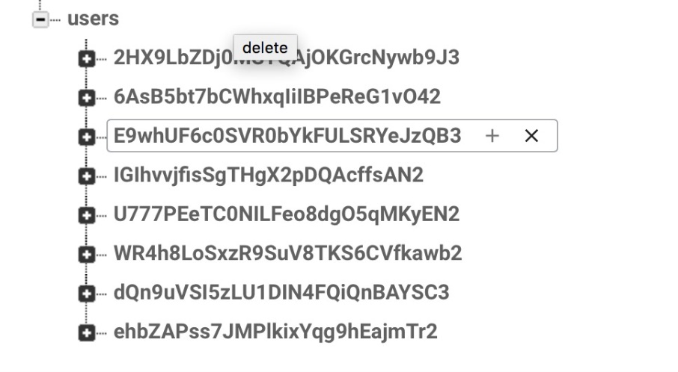

Figure 25 : ‘users’ DB and child nodes

Under each registers user’s node, there are all the information related to the users; name, age, gender, id (which is the device Id) and token to be used to cloud messaging (see Figure 26 below).

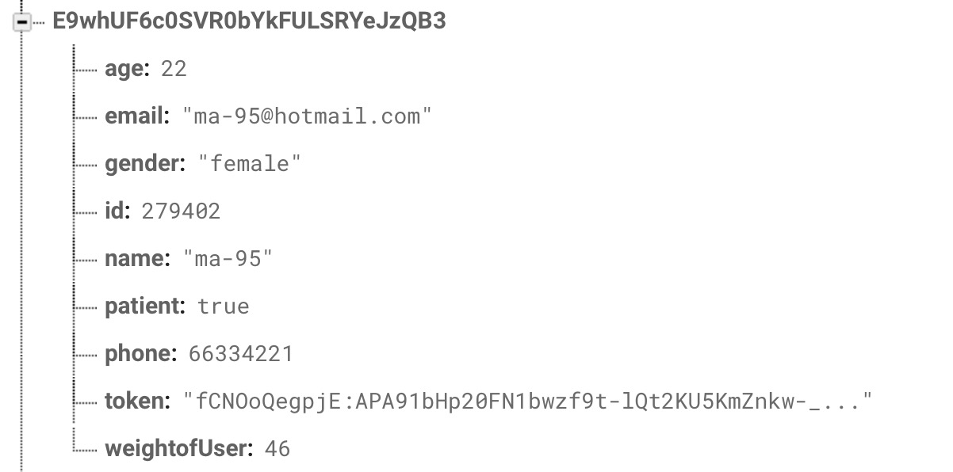

Figure 26 : Single user node information

## User interface design

Our system has two user interfaces, both are friendly and easy to use. The patient side is to add the data and view the history while the doctor side is to view all the patients’ data and history then notify in case of any abnormality.

MediCheck application screenshots are added with a brief description::

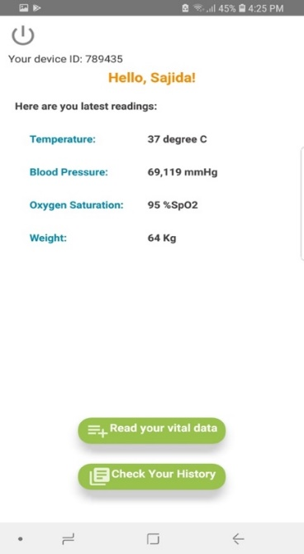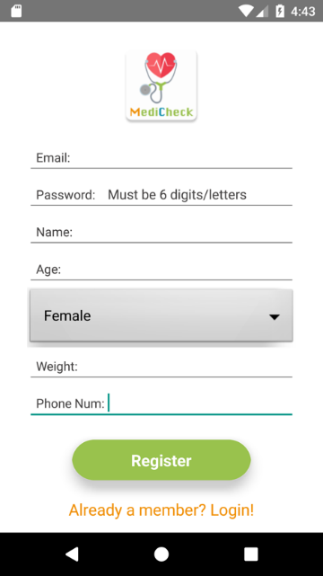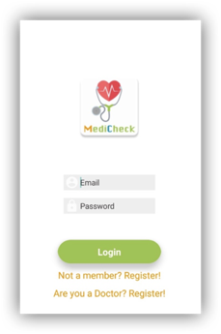

Home page

Patient side:

Login page

Registration page

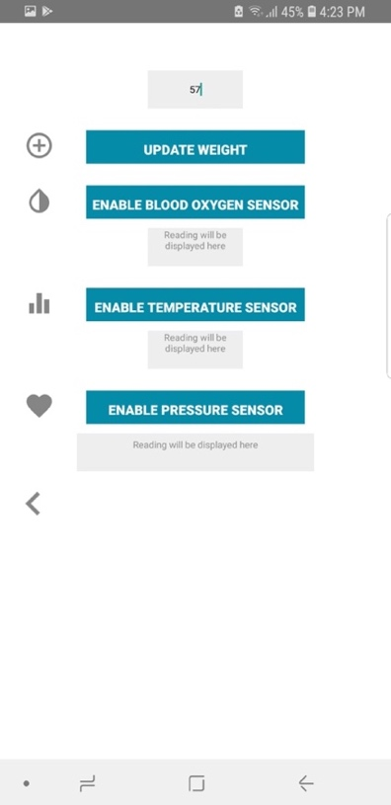

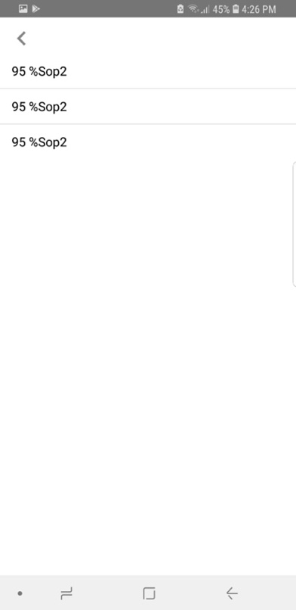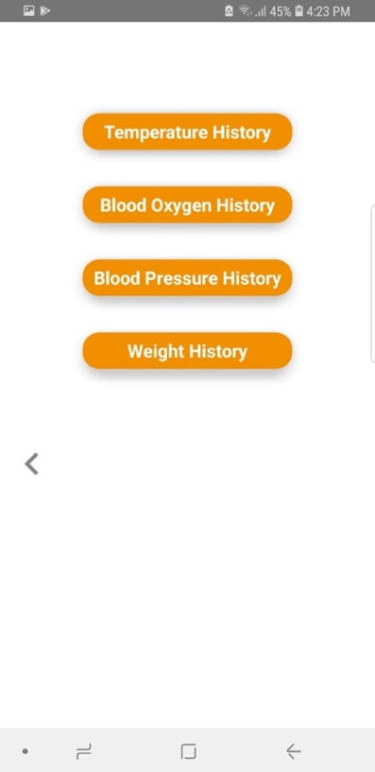

History page

Reading data page

Viewing specific sensor history page

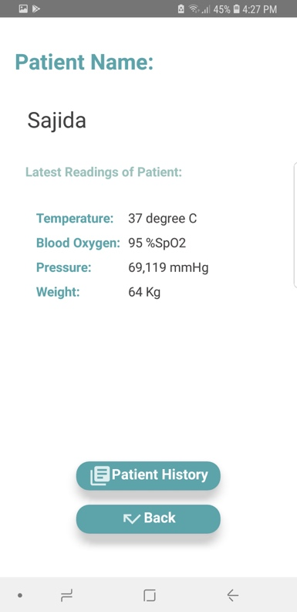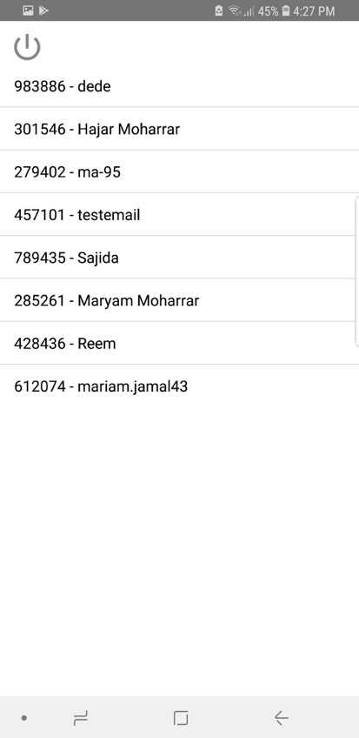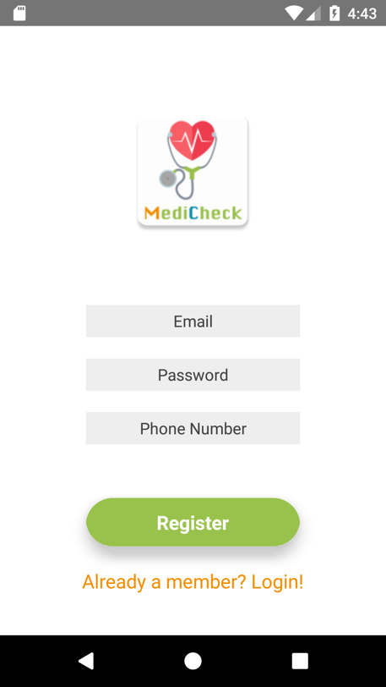Doctor Side:

Registration page

Patient History page

Home page

Login page

# **Implementation**

Implementation of E-Health monitoring system consists of hardware (E-health device) and three main software:

1. Android application development environment that provides control on the E-health sensors. The application acts as an interface between the E-health device sensing and the patient.
2. Arduino IDE which is a C code environment. Used to build up our code for ESP8266 board and Arduino Uno.
3. Firebase cloud, which is the interconnection between mobile application and hardware (E-health device). Firebase database used to store user health data, and firebase cloud functions to do some processing on user data before storing it in the database.

## Android application development environment

Android Studio was chosen to be the platform to develop E-health monitoring system for it is a free open source to develop apps for android systems, as well as more than 40% [37] of users world widely and more than 43% [38] of users in Qatar are using Android OS based smart phones In this section, we are mentioning more details of implementation milestones that the app went through in order to achieve the functionalities that are important for the E-health monitoring system.

### **Connecting android application to firebase cloud**

In order to connect to Firebase and use it, first thing we have added several implementations to use different Firebase functionalities that are necessary to our system. Figure 27 below contains each implementation added to the bulid.gardle (Module) file in Android Studio and its functionality.

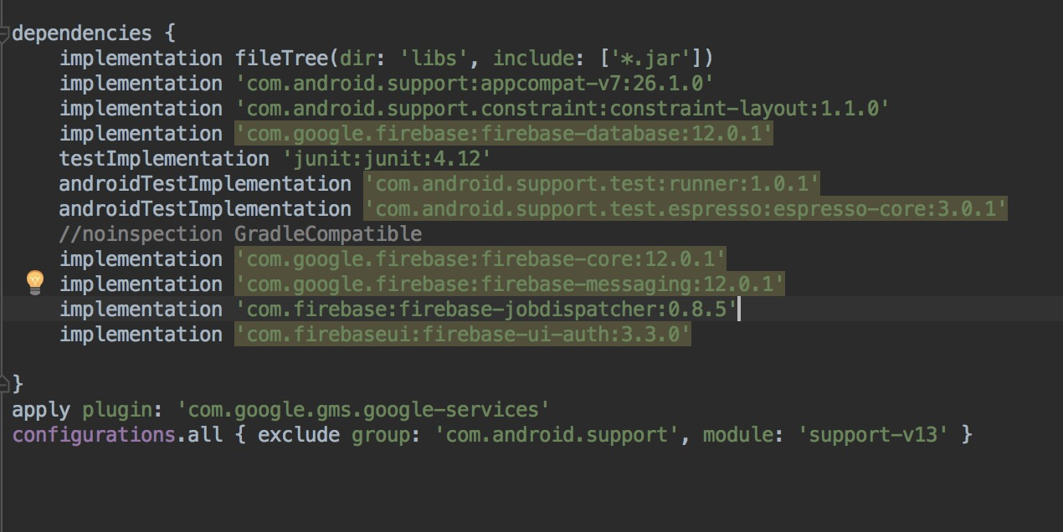

Figure 27 : Dependencies added in build.gradle file in Android

Besides including Firebase implementations, an important dependency that must be added to the gradle.Project is google services classpath. Google services allows the integration between any Android App with other apps that are compatible with Android OS. In this project, we have included google services version 3.2.1 that is compatible with both the build gradle that is version 3.2.1 and all the firebase implementations included that have versions 12.0.1. All these classpaths and implementations must have these versions or any other versions that are compatible to each other, or the application will not be able to establish. This is one thing learned throughout the process of establishing a connection between Android and Firebase.

After adding the required dependencies, to the Android project, we connected it to the Firebase project through adding the package name of the Android project to the Firebase project, and then a google-service.json file was given to be added to the Android project in order to finalize the Android-Firebase connection.

### **Implementing patient User interface**

For the patient interface, a package called patientPackage was created to have all the different activities and views that are related to the patient.   
We have implemented the user authentication provided by Firebase in order to have a secured client side without being able to read the other patient’s critical data. Each patient is assigned with a unique ID within Firebase and this ID is created as a child under the ‘users’ parent node in the database (see Figure 28 below).

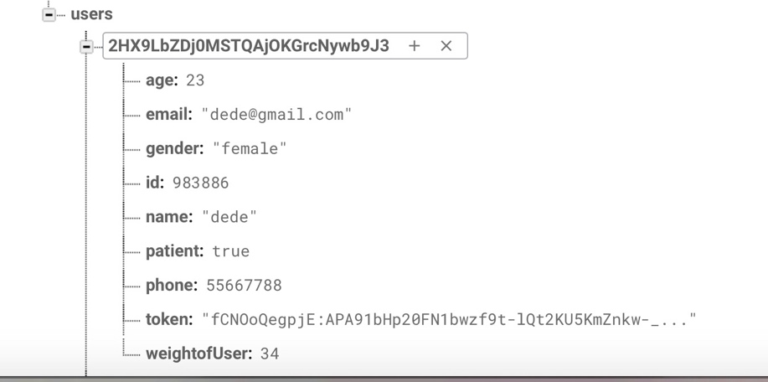

Figure 28 : userID chlild under users parent node

When registered, each user receives a device ID; a random 6 digits assigned number, to be used in order to identify each user when using the sensors. This device ID is used to connect each user’s information with the vital data read by the device to ensure more private environment. This device ID is entered in the device before acquiring any patient vital data to be read.   
Moreover, in the home page, the latest readings of each sensor are displayed to the user and are automatically updated whenever a new data is added. This is done by adding an addChildEventListener; a listener provided by Firebase.authentication package to look for the latest child added under each sensor parent node.   
  
If the patient wants to read new vital data, he/she can select a button in the home page named “Read Vital Data”. When clicked, a new activity is displayed to the user having all the buttons to all the sensors connected to the device. When data is added, the home page sensors’ readings are updated accordingly. When reading the last vital data, the blood pressure, all the data is analyzed in the Firebase cloud functions. If any abnormal data was found within the new readings, a notification is sent to the doctor and the patient to inform both of them about the abnormal data. The user mobile phone number is added to the doctor side notification in case any direct contact is needed.



Furthermore, the patient has the option to view his/her vital data readings. The patient can press on the “View History” button found in the home page in order to do so. When clicked, the device ID is sent with the intent calling the History activity in order to be able to retrieve the sensors readings from the database.

### **Implementing doctor’s User interface**

For the doctor interface, a package called doctorPackage was created to have all the different activities and views that are related to the doctor.   
As with the patient interface, have implemented the user authentication provided by Firebase in order to have a secured client side for the doctor having all the confidential data of the users assigned to a particular doctor.

The doctor’s home page is a listView containing all the patient assigned to the specific doctor. In each row, the patient ID and name is displayed. In order to display more information about the user, the doctor has to select one of the users. When a user is selected, the patient device id is sent as an extra with the intent calling new activity. It is used to retrieve the patient sensors data to be viewed by the doctor. When the new activity is opened, the patient name and latest sensors reading are displayed to the doctor.   
Moreover, the doctor has the option to see the patient’s vital data history. This is done by selecting the button named “Patient History”. When selected, the patient device Id is sent with the intent calling the new activity in order to use it to retrieve the patient sensors readings.

## Hardware and Software Implementation for ESP8266 NodeMCU

### **Connecting ESP8266 NodeMCU to WIFI network and Firebase cloud**

The uploaded code to the ESP8266 includes the necessary WIFI connection configuration. It is configured with the local Wi-Fi network SSID and password, to let the ESP8266 recognize and establish the connection to the Wi-Fi network if it is available. Once the connection to the WIFI network established then immediately starts the connection to Firebase cloud. For Firebase cloud connection we need also to configure it with the necessary Firebase hostname and Authentication key. We included special libraries in Arduino IDE for both connections the WIFI network and Firebase cloud. Table 11 shows these libraries with their descriptions. Another purpose of using Firebase libraries is to allow sensors measurements to be sent to the database and retrieve from it any necessary values. There is a specific device ID assigned to each user and based on that ID a unique path is created on the database and all user measurements are sent there.

### **Connecting 4x4 Keypad and LCD display(16x2) to ESP8266 NodeMCU**

The ESP8266 NodeMCU has main three hardware connectivity. It has connectivity with 4x4 keypad, LCD display(16x2) and serial connection with Arduino Uno. For the hardware connection details, you can refer to section 4.4.1 which contains all pin assignments and connections. On the other hand, for the software implementation we included special libraries in Arduino IDE to use the keypad and LCD display which are mentioned in table1. After including the necessary libraries, we were able to use the components (keypad, LCD) perfectly. Specifically, the keypad has been used to enable the user entering his device ID. Afterwards, the program takes the ID and check in firebase database if this ID is already existing for one of the users or not. The result of that searching is displayed for the user on the LCD display. Incase that the ID is correct it displays to the user that the connection to the firebase is done, otherwise it displays an error message and allows the user to re-enter the ID again. Eventually, If the user correctly enters his ID the program then creates a unique path for that user in firebase database. More details about the program flow is showed in ESP8266 NodeMCU flowchart in section 4.5.2.1.

Furthermore, the LCD display has one main functionality that indicates the status of the device to the user (e.g. Connecting to WIFI, Wrong ID re-enter again). Accordingly, the user will know what to do and react based on that. Following is the table of libraries used in ESP8266 NodeMCU code. Figure 29 is showing the used keypad, LCD display and NodeMCU.

|  |  |
| --- | --- |
| Name of Library | Description |
| ESP8266WiFi.h | This library gives the ability to the ESP8266 module to connect to the internet. It has been developed based on ESP8266 SDK, and uses the functionality philosophy of Arduino WIFI library. |
| FirebaseArduino.h | This library is responsible for ESP8266 board connectivity to Firebase cloud. It gives the ability of sending and receiving data to and from Firebase database. |
| ArduinoJson.h | a C++ JSON library for Arduino and IoT (Internet of Things). It allows us to send and receive JSON objects to and from Firebase cloud |
| Keypad.h | This library is for using matrix style keypads with the Arduino. It has been used to allow user to enter the device ID. |
| LiquidCrystal_I2C.h | This library is for using 16x2 LCD display. It Used to add user interface for the user. |
| Wire.h | This library allows you to communicate with I2C / TWI devices. It has been used to facilitate the connection with LCD display that uses I2C. |

Table 11. ESP8266 NodeMCU Arduino IDE libraries

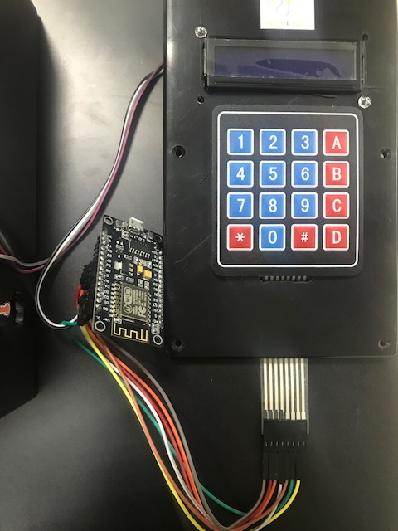

Figure 29 : NodeMCU with 4x4 keypad and 16x2 LCD

## Hardware and Software Implementation for Arduino Uno

In our system Arduino Uno is the main microcontroller that is responsible of reading the E-health sensors measurements. For reading the sensors measurements an additional shield has been added which is My-signals HW shield, all the E-health sensors have been plugged directly on My-signals shield. Hence, the My-signals shield is fixed above Arduino Uno, for more details about the hardware connection you can refer to section 4.4.1 which contains all pin assignments and connections. After having all necessary hardware components connected and well-integrated, we started the coding part with Arduino IDE by including the required libraries. Table 12 is showing all the libraries included in Arduino Uno program. At the beginning of the program we have initialized a new software serial connection to communicate with ESP8266 NodeMCU. As a result of My-signals usage to the hardware TX and RX of Arduino Uno, we have used Digital pin 2 and 3 as RX and TX respectively. Thereafter, the program enables the E-health sensors based on the user choice. For SPO2 and blood pressure sensors there is a special command that must be called to enable and disable them, in particular MySignals.enableSensorUART(SENSOR_NAME) and MySignals.disableSensorUART(). More details about the program flow is showed in Arduino Uno flowchart in section 4.5.2.2.

|  |  |
| --- | --- |
| Name of Library | Description |
| MySignals.h | This library is used to manage all my-signals sensors integrated in the main board. It has the basic functions to monitor the biometric parameters. |
| SPI.h | This library allows you to communicate with SPI devices with the Arduino as the master device. It has been used for the communication with my-signals sensors. |
| SoftwareSerial.h | This library allows serial communication on other digital pins of the Arduino. It has been used to connect to NodeMCU. |
| Wire.h | This library allows you to communicate with I2C / TWI devices. It has been used to facilitate the connection with my-signals sensors. |

Table 12. Arduino Uno Arduino IDE libraries

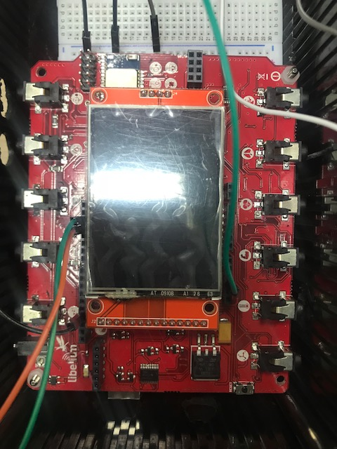

Figure 30 : My-signals shield above Arduino Uno

## Firebase cloud

To have a project in firebase cloud we have first created a Gmail account and then logged in to Firebase cloud by that account, see Figure 31. Then we created project in firebase, see Figure 32. Finally, we can use now Firebase cloud. In our project implementation we have basically used Firebase real time database to store the user’s data and Firebase cloud functions to compute and process user’s data in the cloud.

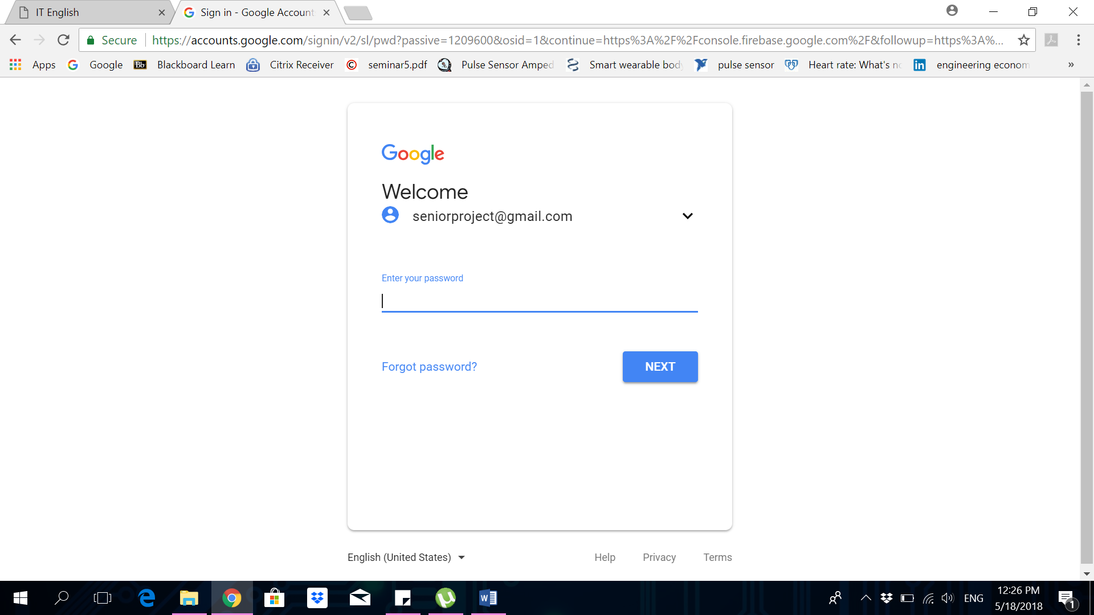

Figure 31 : Create Gmail account

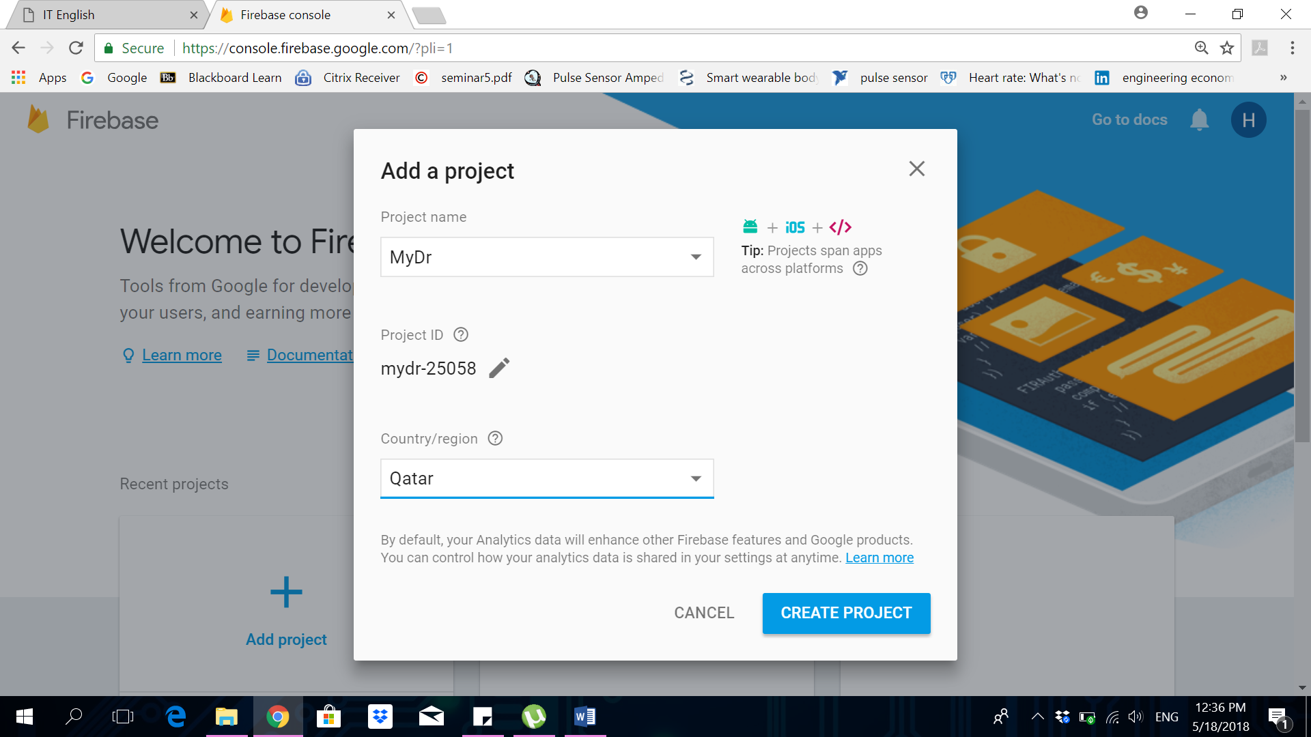

Figure 32 : Create new project in Firebase

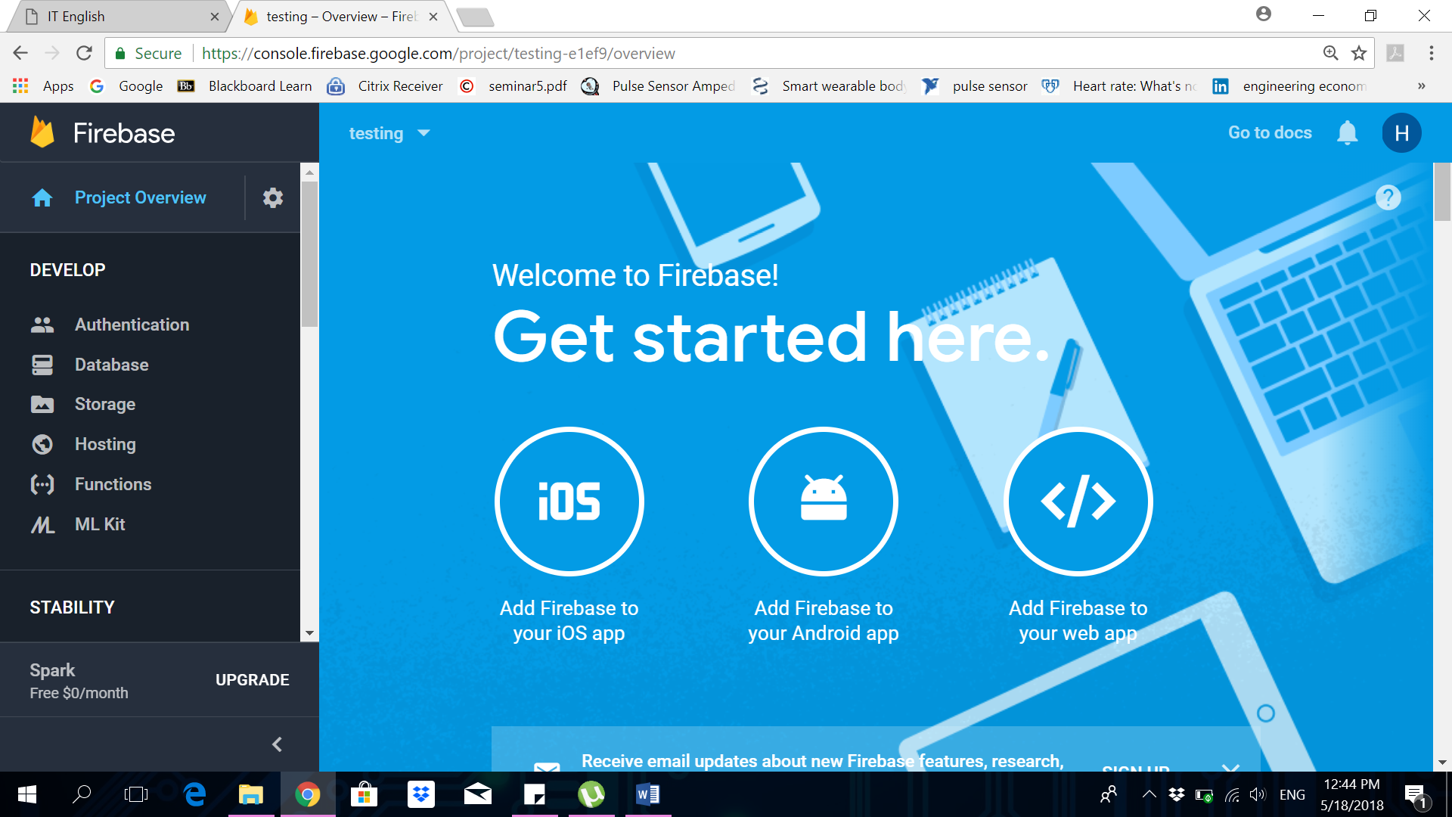

Figure 33 : Firebase console

# **Firebase real time database**

The user data is saved first in the firebase database and then retrieved back by the user application and displayed. We have started with Firebase real time database by defining the rules and the structure of the data saved in it. To be able to send and receive data to the database we defined the database rules of read and write as true which allows everyone has a reference to the database to read and write to it, see figure 34. Additionally, we have structured our data in firebase database in a way that we have doctor’s node, user’s node and reading’s node. The user’s node will include all the users in our system with their signing in information. Similarly, this apply to the doctor’s node. Whereas, the reading’s node will include user’s vital measurements. The connection point, however between the user ‘s node and reading’s node is the device ID that is generated by the Android app. To conclude, the user’s node contains the device ID as well as the reading’s node, where all the user readings will be saved under his device ID in the database. See figure 35, which shows the database structure.

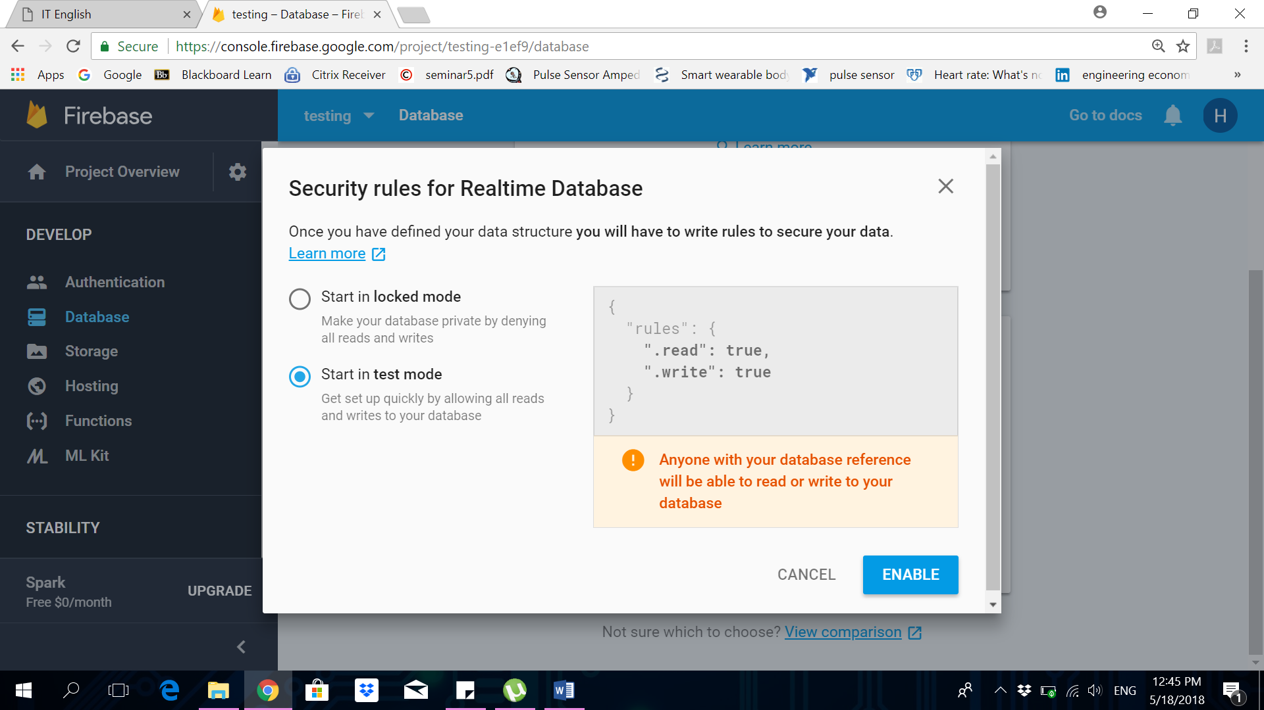

Figure 34 : Firebase database rules

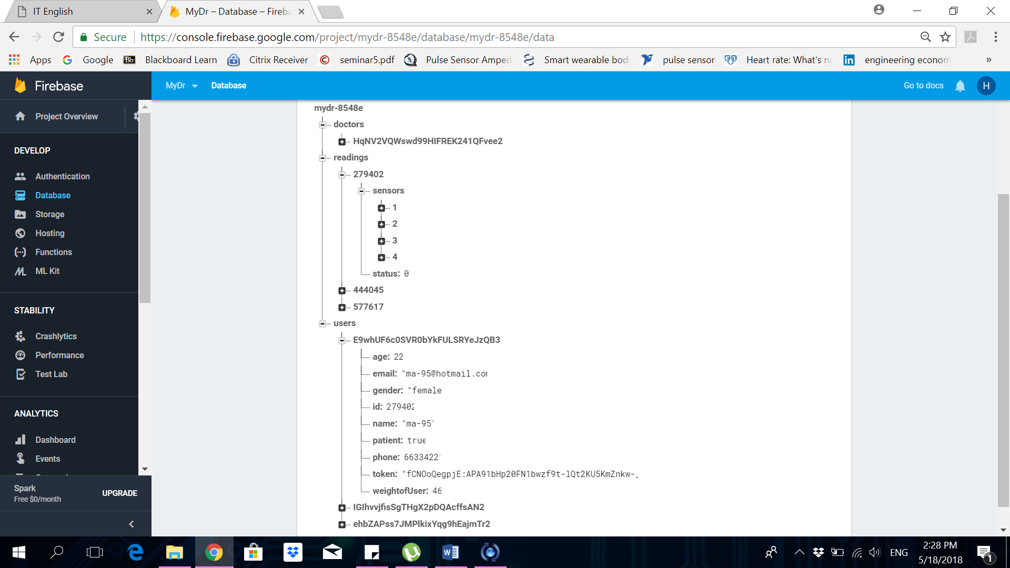

Figure 35 : Firebase database structure

# **Firebase cloud functions**

Firebase Cloud Functions give the ability to automatically run backend code in response to events triggered by Firebase features and HTTPS requests. The code for the system functions is stored in Google's cloud and runs in a managed environment [40]. The cloud functions can respond to events generated by cloud firestore triggers, real time database triggers or other type of triggers [40]. The main reason of using firebase cloud functions in our project is to analyze and process the patient’s data that are saved in the database, in a way that compares patient’s data with the abnormal measurements range to notify the patient and the patient’s doctor in case of emergency. To start using cloud functions, we had first installed Node.js developing environment, and then installed firebase CLI to create a project and set up the functions feature. These steps are being done using command terminal as shows in Figure 36.

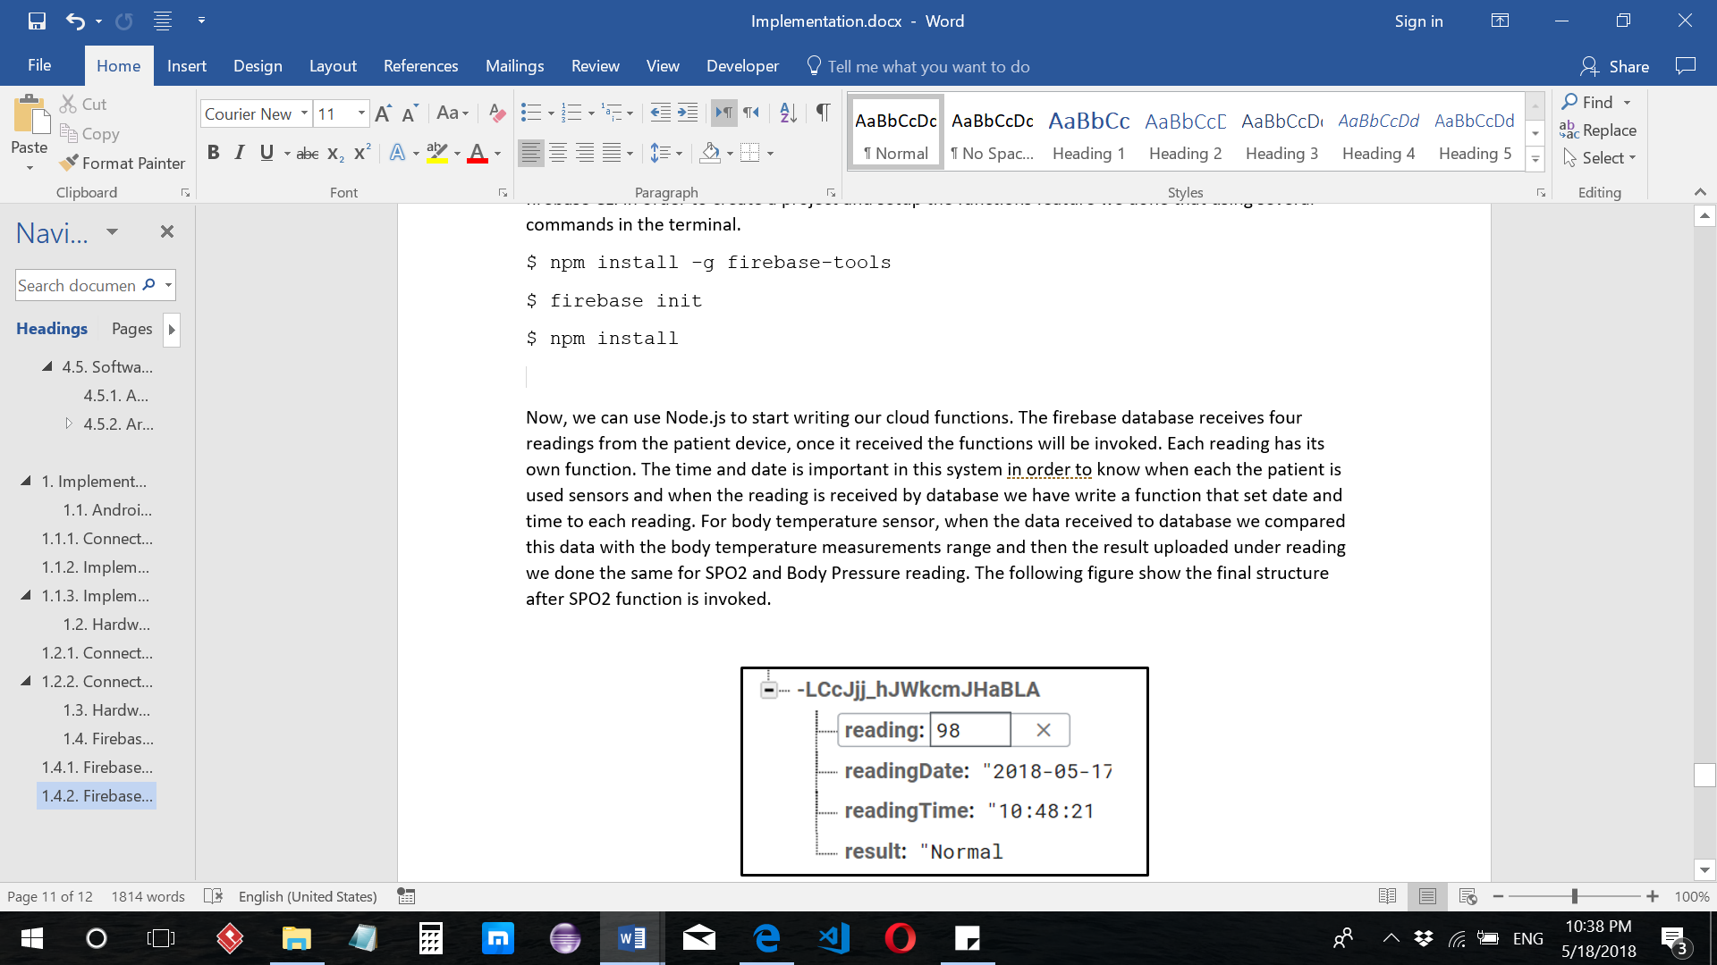

Figure 36 : Firebase installation command

After this action, we used Node.js to write our cloud functions. In addition, we have used Visual studio code to write and deploy our cloud functions. All the cloud functions we have written are triggered when any new data is added to the database. The firebase database receives four readings from the patient device, once the data arrives to the database the functions will be invoked. Each sensor reading will invoke it is own function that is responsible to process the incoming data and determine whether the reading is normal or not. Additionally, each function adds the time and date to the readings. Adding time and date to the reading is important for the patient “Weight”. This function compares the new weight reading with reading of weight the day before. Moreover, the function benefits the physician when visualizing the historical data of the patient.

For the SPO2 sensor, when the data reading reaches the database, the SPO2 function compares this data with the SPO2 measurements range and then adds the result, time and date under the reading as shown in Figure 37. The same procedures done for temperature and blood pressure readings. Figure 37 shows the final structure after SPO2 function is invoked.

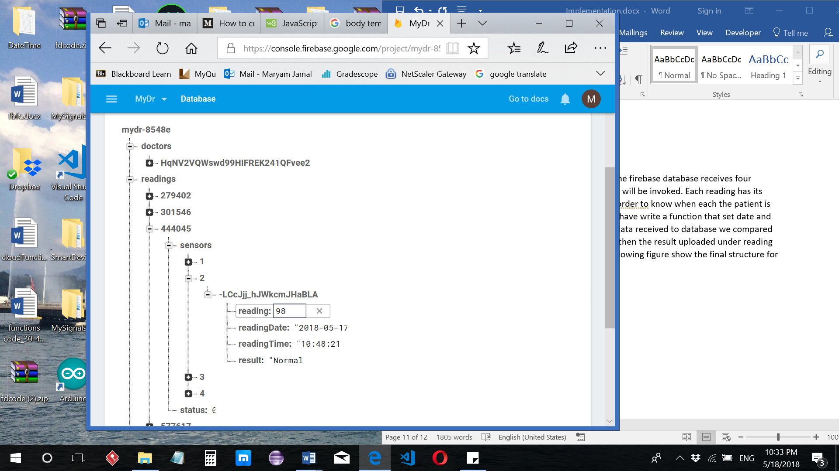

Figure 37 : SPO2 database structure

The weight reading’s function has different processing algorithm than all other sensor reading’s functions. In the weight’s function the processing in the cloud is to compare the current weight reading with the previous reading on day before. The reading will be considered abnormal if there is an increase in the weight by 0.5Kg or more and the result of the processing will report “Weight increase”. Figure 38 shows two reading in different days.

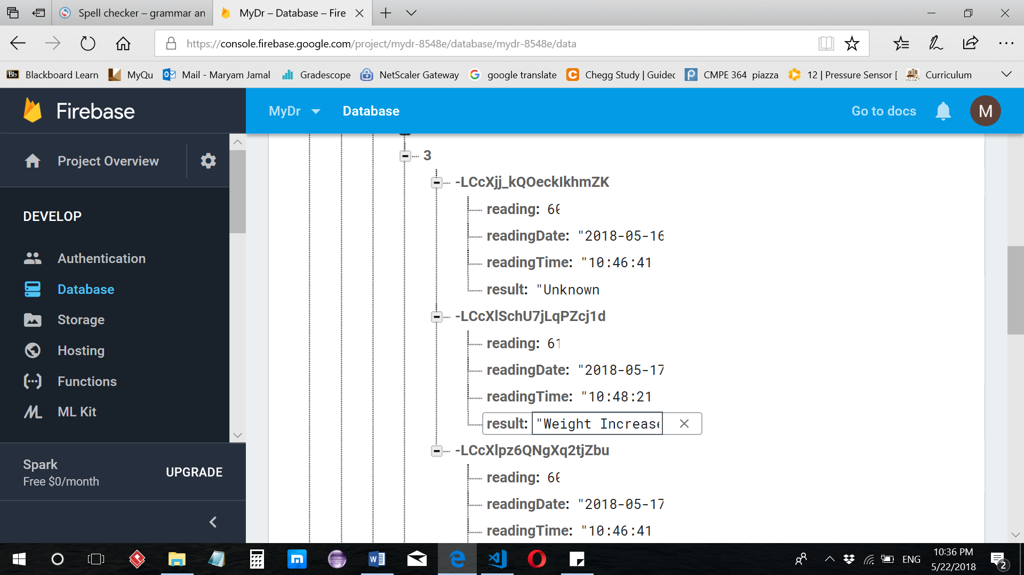

Figure 38 : Weight database structure

In addition, a cloud massaging function has been written in order to send notification to the physician and patient if any of the patient’s last readings shows abnormality. This function is a special function in a sense that it needs the unique id for each user’s mobile called token to be able to send the notification. The function retrieves all reading’s result and check if at least one reading is an abnormal. In this case, a notification is forwarded that contains all the patient’s information and measurements with their results to the physician and patient informing them that there is abnormal reading. Otherwise, a notification will be sent to the patient informing him that he is in a stable state. Figure 39 shows a sample doctor notification.

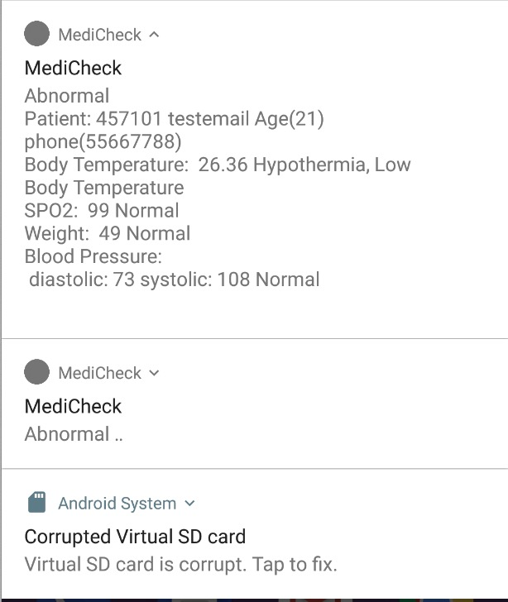

Figure 39 : Doctor Notification

The flowchart in Figure 40 is also presented in this section for the reader convenience that show the workflow for all cloud functions code.

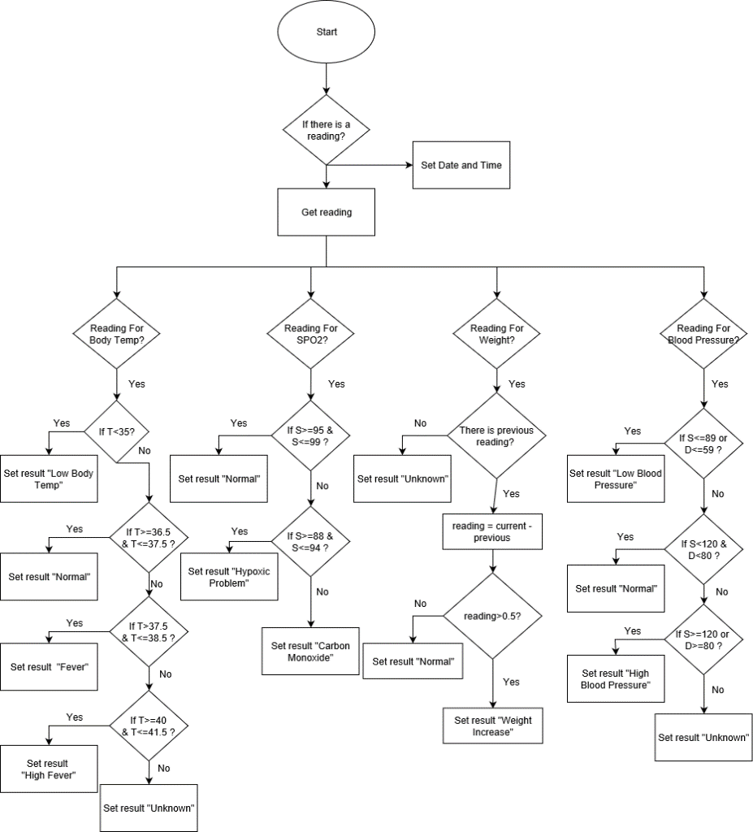

Figure 40 : Firebase Cloud Functions Flowchart Diagram

# **Testing**

In this phase of the project development we have used several testing mechanisms to determine the usability, reliability and many other constraints of the system. Two approaches are used to test our system: (1) System connectivity testing, (2) system usability testing. The tests are conducted as follows:

## System Connectivity Testing

Testing the connections of the system is done by measuring the required time to connect the components (ESP8266 and mobile) to the internet and observe the time on the timer. The testing will be conducted in multiple stages: (1) The internet development board ESP8266 NODEMCU connection to WIFI network, (2) ESP8266 NODEMCU connection to Firebase cloud, (3) ESP8266 NODEMCU sending sensors data to firebase, (4) Application Receiving sensors data from firebase.

### **Testing the connection of ESP8266 NodeMCU to a local wireless Network**

The testing of the connection was done by setting the timer and then connecting ESP8266 to the Wi-Fi network. Figure 41 and 42 are showing ESP8266 before and after connecting to the network. From Table 13 below we can see that ESP8266 takes a short time to connect to the Wi-Fi, the average connecting time got is 00:04.5 seconds. Figure 45 is showing that this connection takes the longest time among all of the other connections.

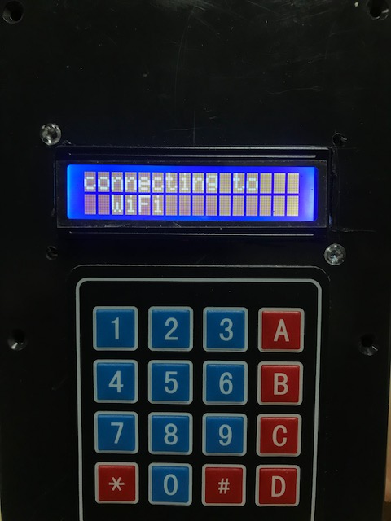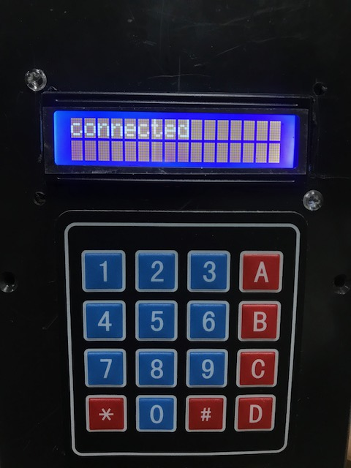

Figure 41 : Before connecting to network

Figure 42 : After connecting to the network

### **Testing the connection of the ESP8266 NodeMCU to the Firebase cloud**

After guaranteeing the connection of the ESP8266 to the Wi-Fi network, The ESP8266 must be connected to firebase cloud. To show that the firebase cloud is reached by the ESP8266 an LCD display is used. The LCD displays the result shown in Figure 43. The text colored in orange and green in Figure 44 shows that a new device ID is added to the readings node after the connection. A timer also has been used here to check the duration needed for the connection and the result is listed in table 13 (Firebase Cloud). An average connection time required to make the connection to the cloud is 00:03.6 seconds. See Figure 45 that shows comparison between the average time needed for all the connections.

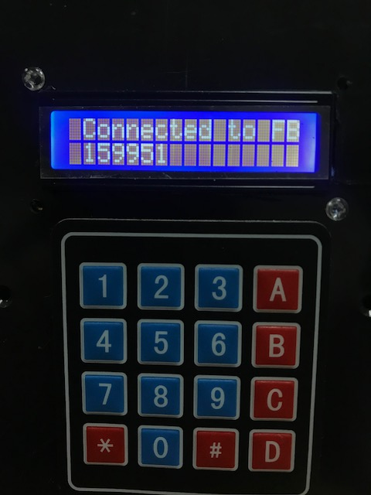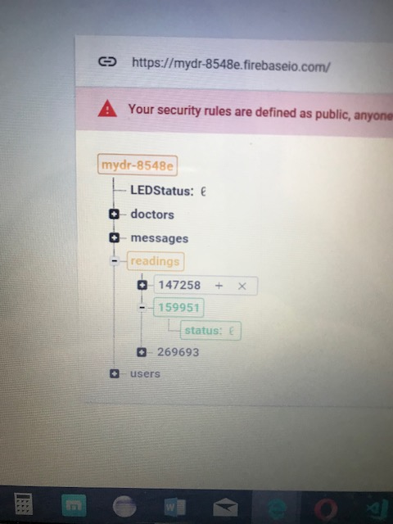

Figure 43 : Connection to firebase

Figure 44 : New Device ID added in firebase

### **ESP8266 NODEMCU sending sensors data to firebase**

The firebase database has been used to observe the sent data from the sensor to the cloud. The data of the user is saved first in the firebase database and then retrieved back by the user application and displayed. For this test we have only measured the time for the sensors data to be sent to the firebase database. We have used the temperature sensor to test this connection. Table 12 (sending sensor data to cloud) is showing the time of sending the data to firebase database. An average sending time required to send data to cloud is 00:03.0 seconds. See Figure 45 that shows comparison between the average times needed for all the connections.

### **Application Receiving sensors data from firebase**

|  |  |  |  |
| --- | --- | --- | --- |
| *ESP8266 Node MCU v0.9 connection time:* | | |  |
| Trials | **Wi-Fi Network(s)** | **Firebase cloud(s)** | **Sending sensors data to cloud(s)** |
| 1 | 00:05.41 | 00:03.67 | 00:03.36 |
| 2 | 00:04.58 | 00:03.58 | 00:02.60 |
| 3 | 00:06.02 | 00:03.73 | 00:02.30 |
| 4 | 00:03.99 | 00:03.48 | 00:02.69 |
| 5 | 00:03.96 | 00:03.44 | 00:03.00 |
| 6 | 00:04.20 | 00:03.64 | 00:03.34 |
| 7 | 00:03.58 | 00:03.63 | 00:03.09 |
| 8 | 00:05.22 | 00:03.55 | 00:02.72 |
| 9 | 00:03.86 | 00:03.43 | 00:03.06 |
| 10 | 00:04.52 | 00:03.70 | 00:03.46 |
| Average | **00:04.5** | **00:03.6** | **00:03.0** |

The Android application is used by the patient to view the data received from the firebase cloud after being transmitted by the ESP8266 to the cloud. Therefore, a timer has been used to figure out the time needed for the data to be delivered to the application from the firebase database. The timer starts immediately after the sensor data is set in the database, the results are showed in table 14 on Average the time required to retrieve data by the mobile app is 00:00.97 seconds. Figure 39 shows that this connection has the lowest time among all other connections.

Table 13. ESP8266 Node MCU v0.9 connection time Analysis

|  |  |  |  |  |  |  |  |  |  |  |
| --- | --- | --- | --- | --- | --- | --- | --- | --- | --- | --- |
| ***Application connection time to*** | | | | | | | | | |  |
| **Trials** | 1 | 2 | 3 | 4 | 5 | 6 | 7 | 8 | 9 | 10 |
| **Receiving sensors data from cloud (s)** | 0.82 | 0.43 | 0.89 | 0.95 | 1.02 | 0.99 | 1.33 | 0.96 | 1.38 | 0.93 |
| **Average** | 0.97 | | | | | | | | | |

Table 14. Application connection time Analysis

Figure 45 : Average time connection

## System Usability Testing

The second phase of the testing milestone in our project was the usability of the system. We managed to find 10 of our university colleagues and asked them to use MediCheck system. After that, we also asked them to fill a short online questionnaire in order to get their feedback about what they think of the overall system. During this process, we received so many comments on the user interface of the application to improve the user experience of our system. All the comments were taken seriously, and some are critical and have been incorporated in the revision process of the system design and in subsequent further system improvement. One comment, for instance, on the activity views as they were fixed and not scrollable. In other words, when the mobile device’s keyboard was on, it obscured the rest of the items on the screen and the user had to scroll down the keyboard in order to see the other screen items. Another comment we received is regarding the ‘Read you Vital Data’ activity. The buttons do not show that it is clickable. For this, we added a fading effect, as when the user clicks the button, the button is animated with a fading effect. Other comments were on the application background color that it was a dark blue color, which is a bit not comfortable for the eyes. This issue was resolved by unifying the application color theme to be white color background, and colorful view items; orange, light blue and light green, for the application to look more modern and comfortable for the eyes. Another comment was in the patient sign-up screen. They have suggested to add a selection view for the ‘Gender’ in order to select an option; female or male. These were all the comments received by the 10 users and what we have done in order to improve the application design and user experience.

After looking at the users’ survey answers (Figure 46 below) we can conclude that their experience with MediCheck system was good in overall. The first column on the leftmost, shows that 50% of the users agreed to use the system frequently, 40% were neutral, and only 10% strongly disagreed. The next column indicates that 80% of the users found the system simple and not complex, and only 20% thought that the system is a bit complex. Looking at the sixth column from the left, 80% of the users found the system consistent and only 10% found the system inconsistent. Lastly, from the rightmost column, 80% found that the system is easy to use and does not require a previous background in order to use it, only 10% agreed that they need to acquire a previous background in order to know how to use MediCheck system.

Figure 46 : Users impression on MediCheck system

## Design constraints evaluation

In this section, we discuss our project design constraint evaluation which are: technical constraints and practical constraints.

|  |  |  |  |
| --- | --- | --- | --- |
| Name | Description | Met/Not Met | How the design was met? |
| Availability | the application will be available all the time and the sensor will be ON when the patient is using it. | $$√$$ | The android application can be available all time for doctors and patients, once is downloaded into the mobile devices at both ends. However, the system should be connected through the Internet, in order for NodeMCU, Fiberbase, and Android devices to be connected and communicate through. |
| Performance | Application performance must perform within a minimum response time, to meet the requirements of the QoS. | $$√$$ | Even with this system prototype, the connection of the system parts together takes a short time.  With more proper sensors and system components, the performance time would not be an issue. |
| Reliability | No data loss is allowed as all the data will be saved and back up while the mobile is connected to the internet. | $$√$$ | The vital measurements received correctly to the patient. In addition, the notifications massages received by the doctor and the patient are very clear way. For example, in case of abnormality the vital measurement values send with the exact result (exactly the abnormal measurement). |
| Connectivity | While reading the data from the sensor the mobile application need to be connected to the internet.  Firebase database need to be connected all the time. | $$√$$ | Firebase database is connected to NodeMCU and android which are always connected to the internet. |
| Efficiency | Time taken to transfer the patient data to the firebase cloud must be as low as possible.  Time taken to send notification for doctor in emergency case must be as low as possible | $$√$$ | The time taken for the patient data to be delivered to firebase takes in average 3 seconds.  The notification takes less than 3 seconds to be sent to the doctor. |
| Scalability | Our design will be handle more users in future and we can add more sensor and components to the device. | $$√$$ | The system can handle large number of users just by increasing buffer size.  The MySignals board is able to work with 11 sensors, which is more than the physician needs to know about their patients. |
| Usability | For the device, it must be design carefully to simplify the using of these sensors on the target patient. | $$√$$ | The hardware device is easy to use since with a user interface like LCD display being carefully designed and built. Also, patient and doctor application interface are clear and easy to be used. The usability for the application was tested (see the section on testing). |
| For the user interface, which is running on the mobile app must be user friendly and easy to use by any user. | $$√$$ |
| Portability | The application can only work in android platform. | $$√$$ | The application built using android studio which can only be downloaded on any android device, including phones, tablets, Laptops, etc.. |

Table 15. Technical design constraints

|  |  |  |  |  |
| --- | --- | --- | --- | --- |
| Quality | Name | Description | Met/Not Met | Verification |
| Economic | Design Cost | Our system has multiple biomedical sensors that need to be precise in order to get precise data; where precise sensors cost higher prices than any other sensors. | $$√$$ | The prototype system cost around 3867 QR, which is less than the budget we received from university. |
| Time | Development Schedule | Implement security if time allowed us. | X | The research team investigated methods for making the communication channels connected to the cloud more secured. These are discussed in the report, but due to the project time frame the security part was not implemented. |
| Environmental | User need | Patient should follow the set of instructions that is provided. It should also explain how to connect the sensors correctly. | $$√$$ | A set of guidelines for using the application given in a booklet, and the application homepage. These can be provided to both patients and physicians. |
| Social | Government codes | All the data of patients are secured and only viewable by their doctor. | $$√$$ | Each doctor will have its own account, which will be used to view the patient’s data, so all the data will be viewed only by the doctor. |
| Ethical | Privacy | All the data of patients are private from the public. |
| Manufacturability | Transport | The sensors and Arduino are organized and packaged in one box. | $$√$$ | The hardware components of the system are grouped and packed in a one box, which is easy to carry anywhere. |

Table 16. Practical design constraints

# **Evaluation of the impact of the engineered solution**

MediCheck health monitoring system was ultimately designed for the purpose of impacting the lives of patients with cardiovascular diseases who are suffering from sudden heart attacks and high or low heart beat rates. By the help of the sensors connected to the device, patients’ vital data has been able to be read and saved in the database as a reference for the doctor. The aim of the system was to ensure that patients with cardiovascular disease have their vital data recorded to be analyzed within the system to look for abnormalities. Once an abnormality is found, the patient and doctor are notified about it, and the patient mobile number is added to the doctor side notification in case the doctor wants a direct contact with the patient.  
Moreover, our system solution can be beneficial for other engineering solutions whether it is related to the medical field or any other field, since the integration between cloud and mobile application made a revolution on the communication tools, unlike the wireless where both devices should be connected into the same access point, by then the system cannot be used at home and telepathy of patients will not be achieved. Therefore, in order to evaluate the project, we should see whether this project was effective, achieved its goals and the results had any impacts in term of global, economic, environmental and societal impacts. The table below discusses the level of impact for specific contribution through the project.

|  |  |  |  |
| --- | --- | --- | --- |
| No | Evaluation Context | Specific Contribution through the Project | Level of impact |
| 1 | Global | Our project can be useful globally. Cardiovascular diseases can be found anywhere. And since the system is primarily in English language, then it can be used in the majority of the countries. Arabic version of the Mobile application will be implemented as a future work. | High |
| 2 | Economical | Our system is built with a moderate cost for hospitals to buy it and sell it with a low cost for patients.  The cost of the device may vary according to the sensors quality. | Medium |
| 3 | Environmental | All components used, such as sensors and controllers, have no negative effect on the environment. | Medium |
| 4 | Societal | Our health monitoring system is a good medical device that can be used for telepathy of cardiovascular disease patients.  The user can use it at home and be notified if any abnormality occurred, as well as the doctor supervising the user is notified about the abnormality in order to take a quick action towards it. | High |

Table 17. Evaluation of Engineering Impact

# **Conclusion**

It is concluded from the text above that the design of the project was achieved successfully with the help of using an IoT based application. In this project, we proposed an IoT solution, incorporating Firebase for cloud functions, analyzing the data and using its real-time database, Android Studio for mobile application development, Arduino IDE for sensors and microprocessor handling and the hardware device and sensors to read data and can be used easily at home. The implementation of the project’s solution started first by setting an area of focus, which was a system that can be useful in the medical field, where a device can help doctors be aware of the patient vital data which allows them to have a direct interfere once an abnormality is occurred. This was achieved through Firebase that provides an easy way to read and write data from sensors with the help of the mobile application. In this study, a comprehensive literature review was conducted, followed by an analysis of some applications in which similar ideas based on cloud communication and processing have been implemented. The knowledge gained from the literature reviews and study helped greatly in building the system. The project progressed through many steps including design, implementation and finally testing to ensure that the system met its requirements. Surely, many challenges were encountered during the implementation phase; however, the team was able to overcome them. The project was implemented successfully. Firebase is used to integrate the mobile application with the sensors that are attached to Arduino Uno that is in turn is attached to WiFi board NodeMCU. Both, the patient and the doctor, will benefit from this application since the patient will play the vital role in the process of reading his/her vital data and the doctor will be the one who intervenes when the patient has an abnormal data. The timeline created was adhered to; all the parts were integrated and worked in a way that exceeded expectations; the team would have made improvements and added more features to the prototype if given more time, which will be further discussed in Section 9.

# **Future Work**

As the time was not sufficient for us to implement further improvement in MediCheck system, future work that can be done on this project are listed below:

* Secure the system from all perspectives. Securing the channels of communication as well as the database. As mentioned earlier, the system deals with confidential vital data, which needs to be protected from all unauthorized people.

Note: Dr. Unal who is a cyber security specialist working in KINDI in Qatar university, gave us some recommended solutions related to security. One of these recommendations is using Raspberry pi instead of Arduino Uno since it has more computation power [39], which is needed for the encryption algorithm.

* Use more accurate sensors. And Adding Body Scale sensor, which is a parameter needed in our system.
* Provide GPS feature, to send patient’s location to the doctor in case of an emergency.
* Develop an iOS application for iOS users.
* Add other languages for the application, most importantly Arabic for elderly people to understand the application.
* Change some sensors in order the system to be applicable for patients with other diseases than cardiovascular.

# **Student reflections**

## Diae’s reflection:

They have always said that the best thing that a student will always remember after graduation is the senior project. I strongly believe that I will always be proud of the project that we have accomplished. Though I completed an Android application and development course, the skills and knowledge learnt in this year was furthermore than what I have learned in the past. Dealing with an external, cloud-based database, the communication with two software to be integrated in the same system and applying authentication for the purpose of having different users to ensure some kind of privacy in our application were all challenges that I overcame during the process of implementation of MediCheck system. But nothing seems to be easy done if you do not find someone to support you and motivate you throughout the whole process. Our supervisor was and still our motivator. He gave us a lot of confidence in order to proceed working and learning in order to complete the project successfully. And not to forget my amazing brilliant colleagues who were consistent and hardworking to overcome any obstacle faced in the process of implementing the system. This project is a big accomplishment in my life, and I am definitely thinking about continuing on enhancing the system and having more features to be more powerful.

## Reem’s reflection:

This senior project was the most effective project I have done during my journey in Qatar University. It combines all the principles, rules, and engineering skills that we got from all the courses. It gives me a clear idea of what might be the project in future and how we can start step by step to achieve our goal. The essential point is the new concepts I learnt as most of my work was self-learned which enhanced and qualified me to develop many skills in programming. The difficult I found was in managing my time in addition to the frustration that may happened due to all the stress and unexpected results after long time of working, searching and asking but thanks to my team work who always helped me and found a way to get all the work done well and on time. After a one year working in the project I can say that I have learned many new skills which can help me in the future.

## Hajar’s reflection:

Having a senior graduation project is not something easy as some people might think. The project needs a lot of skills and previous knowledge which we covered in many computer engineering and science courses. This project was of huge value in my experience as a student. During this project I learnt many skills like ability of working as a team, as well as managing the project tasks, collaborating with other team members, and dividing the work to complete the whole project are very important skills that I learned. Hearing about IOT applications for the first time to implementing an IOT application was a great challenge and big achievement. I have gained a lot of knowledge that I did not had before through implementing this project. The most difficult part that I faced is dealing with firebase cloud functions. Start writing these functions was difficult since it uses JavaScript programming language which I did not use before. But after some struggling I was able to deploy the first firebase function. And after seeing many examples on JavaScript I proudly managed to program some functions and finish the processing part in the cloud. At the end I am sure that all the skills and knowledge I have gained will be helpful for me in the future as an engineer.

## Maryam’s reflection:

Working in this project taught me many new things like cloud functions, and Arduino software IDE. In this project I have applied most of what I have learned in my computer engineering and science courses. The senior project made me aware of what a computer engineer could have tasks in the workplace and how to organize the required time to deliver the requirements of the project on-time. We faced many problems during the design and development stage, and it was quite hard to solve these problems without being as a group team, each member brought her own ideas on solving problems. The challenging part for me was writing a firebase cloud functions. As a conclusion, it was a good experience that I work on this project, it was tiring but fun and educational at the same time.

# **References**

1. World Health Organization, “Cardiovascular diseases (CVDs), Fact sheet N°317,” March 2013. [Online]. Available: http://www.who.int/mediacentre/factsheets/fs317/en/. [Accessed 20 December 2017].
2. Retrieved from: <http://www.ece.usu.edu/ece_store/spec/lm35dt-3p.pdf>. Last access: October18, 2017.
3. Retrieved from: https://store.fut-electronics.com/products/nodemcu-esp8266-programming-and-development-kit. Last access: April 10, 2018.
4. Retrieved from: <https://media.digikey.com/pdf/Data%20Sheets/Pulse%20PDFs/PulseSensorAmpedGettingStartedGuide.pdf>. Last access: October18, 2017.
5. Retrieved from: <https://www.cooking-hacks.com/documentation/tutorials/ehealth-biometric-sensor-platform-arduino-raspberry-pi-medical/>. Last access: October18, 2017.
6. Retrieved from: <https://aws.amazon.com/what-is-aws/>. Last access: October 30, 2017.
7. Retrieved from: <https://docs.microsoft.com/en-us/azure/iot-suite/iot-suite-overview>. Last access: October 30, 2017.
8. Retrieved from: <http://cloudino.io/>. Last access: October 31, 2017.
9. B. P. (n.d.). Mobile and Wireless Communications Security.
10. Retrieved from: https://www.wi-fi.org/discover-wi-fi/security. Last access: November 27, 2017.
11. Bhardwaj, A. (2016). Security Algorithms for Cloud Computing, 535-542.
12. Hameed, R. T., Mohamad, O. A., Hamid, O. T., & Ţăpuş, N. (2016, June). Patient monitoring system based on e-health sensors and web services. In Electronics, Computers and Artificial Intelligence (ECAI), 2016 8th International Conference on (pp. 1-6). IEEE.
13. Kakria, P., Tripathi, N. K., & Kitipawang, P. (2015). A real-time health monitoring system for remote cardiac patients using smartphone and wearable sensors. International journal of telemedicine and applications, 2015, 8.
14. Gope, P., & Hwang, T. (2016). BSN-Care: A Secure IoT-Based Modern Healthcare System Using Body Sensor Network. IEEE Sensors Journal,16(5), 1368-1376. doi:10.1109/jsen.2015.2502401
15. Doukas, C., & Maglogiannis, I. (2012). Bringing IoT and Cloud Computing towards Pervasive Healthcare. 2012 Sixth International Conference on Innovative Mobile and Internet Services in Ubiquitous Computing. doi:10.1109/imis.2012.26
16. Securing the E-Health Cloud, Conference Paper · January 2010, by Marcel Winandy.
17. Thomas, S., Saraswat, A., Shashwat, A., & Bharti, V. (n.d.). Sensing Heart beat and Body Temperature Digitally using Arduino. Retrieved October 26, 2017.
18. Aleksandar Milenkovic´ *, Chris Otto, Emil Jovanov. Wireless sensor networks for personal health monitoring: Issues and an implementation
19. Ahmed Lounis, Abdelkrim Hadjidj, Abdelmadjid Bouabdallah, Yacine Challal. Secure and Scalable Cloud-based Architecture for e-Health Wireless Sensor Networks. International
20. Conference on Computer Communication Networks (ICCCN), Jul 2012, Munich, Germany. pp.1,2012.
21. Retrieved from: <https://www.cisco.com/c/en/us/tech/lan-switching/ethernet/index.html>. Last access: December 1, 2017.
22. Retrieved from: <https://www.arduino.cc/> WHAT IS ARDUINO? (n.d.). Last access: November 25, 2017.
23. Retrieved from: <https://www.ieee.org/about/corporate/governance/p7-8.html>. Last access December 17, 2017.
24. Retrieved from: <https://www.acm.org/about-acm/acm-code-of-ethics-and-professional-conduct>. Last access: December 17, 2017.
25. Retrieved from: <https://www.arduino.cc/en/Guide/Introduction>. Last access: October18, 2017.
26. Retrieved from: <https://www.raspberrypi.org/help/what-%20is-a-raspberry-pi/>. Last access: October18, 2017.
27. Rouse, M. (2016, July). Internet of Things (IoT). Retrieved October 25, 2017, from <http://internetofthingsagenda.techtarget.com/definition/Internet-of-Things-IoT>
28. Olafare, O., Parhizkar, H., & Vem, S. (march 2015). A New Secure Mobile Cloud Architecture .International Journal of Computer Science, 12( 2). Retrieved from https://arxiv.org/ftp/arxiv/papers/1504/1504.07563.pdf
29. Mollah, M., Azad, A., & Vasilakosb, A. (2017). Security and privacy challenges in mobile cloud computing: Survey and way ahead. Journal of Network and Computer Applications. Retrieved November 27, 2017, from <http://www.sciencedirect.com/science/article/pii/S1084804517300632>
30. Retrieved from: <https://www.farnell.com/datasheets/1682209.pdf>. Last access: October18, 2017.
31. Retrieved from: <https://www.raspberrypi.org/documentation/hardware/computemodule/RPI-CM-DATASHEET-V1_0.pdf>. Last access: October18, 2017.
32. Retrieved from: <https://docs.microsoft.com/en-us/azure/iot-suite/iot-suite-what-is-azure-iot>. Last access: October 15, 2017.
33. Hamad Medical Corporation, “HMC Annual Health Report 2011,” HMC, Doha, 2012.
34. Retrieved from: [https://aws.amazon.com/elasticbeanstalk/](https://aws.amazon.com/what-is-aws/). Last access:  December 19, 2017.
35. Retrieved from: [https://azure.microsoft.com/en-us/services/app-service/web/](https://aws.amazon.com/what-is-aws/). Last access:  December 19, 2017.
36. Retrieved from: <https://www.diffen.com/difference/Bluetooth_vs_Wifi>. Last access: December 20, 2017
37. Operating System Market Share Worldwide. (n.d.). Retrieved from <http://gs.statcounter.com/os-market-share>
38. Operating System Market Share Qatar. (n.d.). Retrieved from <http://gs.statcounter.com/os-market-share/all/qatar>
39. https://openhomeautomation.net/arduino-vs-raspberry-pi-which-platform-is-the-best-for-home-automation
40. Retrieved from: https://firebase.google.com/docs/functions/?gclid=CjwKCAjw_47YBRBxEiwAYuKdw7nJ6zaEC61by3sxOJbxO6JNmt_jOofRpyqKvNRLyZsaUufD0IFLexoCUEgQAvD_BwE. Last access: May 20, 2018

# **Appendix A - Project plan**

## A.1. Project milestones

|  |  |  |  |  |  |  |  |  |  |
| --- | --- | --- | --- | --- | --- | --- | --- | --- | --- |
| Task | Sep | Oct | Nov | Dec | Jan | Feb | Mar | Apr | May |
| 1. Literature Review: project description and related work |  |  |  |  |  |  |  |  |  |
| 2. Analysis: collecting information related to the project objectives and significance. |  |  |  |  |  |  |  |  |  |
| 3. System requirement and Design: describe and document the functional and nonfunctional requirements, design constraint, design standards and the Assumption. |  |  |  |  |  |  |  |  |  |
| 4. High level solution: describe solution overview, design high level architecture |  |  |  |  |  |  |  |  |  |
| 5. Detailed solution: completing the system design and implementation |  |  |  |  |  |  |  |  |  |
| 6. Testing and Error debugging |  |  |  |  |  |  |  |  |  |
| 7. Delivery of final report and the oral presentation |  |  |  |  |  |  |  |  |  |

Table 18. Project milestones

## A.2. Project timeline

|  |  |  |  |  |  |  |  |  |  |
| --- | --- | --- | --- | --- | --- | --- | --- | --- | --- |
| Tasks | Sep | Oct | Nov | Dec | Jan | Feb | Mar | Apr | May |
| 1. Analysis |  |  |  |  |  |  |  |  |  |
| 1. Literature Research |  |  |  |  |  |  |  |  |  |
| 1. High Level Design |  |  |  |  |  |  |  |  |  |
| 1. Report & Presentation finalizing |  |  |  |  |  |  |  |  |  |
| 1. Detailed Solution |  |  |  |  |  |  |  |  |  |
| * 1. Set up the server. |  |  |  |  |  |  |  |  |  |
| * 1. Implement the Android application. |  |  |  |  |  |  |  |  |  |
| * 1. Set up the sensors hardware. |  |  |  |  |  |  |  |  |  |
| * 1. Implement the Arduino software code. |  |  |  |  |  |  |  |  |  |
| * 1. Check the connectivity between the sensors and the patient device. |  |  |  |  |  |  |  |  |  |
| * 1. Check the overall connectivity. |  |  |  |  |  |  |  |  |  |
| 1. Testing and Verification for the system. |  |  |  |  |  |  |  |  |  |
| 1. Final report & Oral presentation. |  |  |  |  |  |  |  |  |  |

Table 19. Project timeline

|  |  |
| --- | --- |
| Group | Color |
| Team Work |  |
| 1: Hajar+Maryam |  |
| 2: Diea+Reem |  |

Table 20. Project timeline-legend

## A.3. Anticipated risks

|  |  |
| --- | --- |
| Risk Condition | Minimizing Risk Approach |
| The Availability of E-health sensors. | Order the required components and sensors before starting with the project implementation |
| Inaccurate and imprecise results obtained from the sensors. | Search for a sensor with better quality that will guarantee accurate measurements of the body state. |
| WIFI connection failure. | Provide a good shield that will provide stable WIFI connection between the microcontroller and the mobile. A Test might be added to ensure the connectivity to WIFI. |
| Attack patient data while transmission | Use encryption algorithm to secure the transmission channel. |
| Real-time patient data sent to doctor. | Ensure that data is transmitted with minimum delay time. |

Table 21. Anticipated risks

# **Other Appendices**

**Uses Cases Specification:**

|  |  |  |
| --- | --- | --- |
| **Use Case Name:** | Manage Sensors and Arduino | |
| **Brief Description:** | The system receives data from sensors through the Arduino board and processes the data received in Firebase. | |
| **Primary Actors:** | Sensors, Arduino Board | |
| **Trigger:** | Sensors read patient’s health state | |
| **Preconditions:**   * Patient must be registered to the system * Patient must be wearing the sensors device * Patient must enter the device unique ID | | |
| **Post-conditions:**   * Patient’s data is read and processed by the system * The data is saved in the Database on Firebase | | |
| ***Normal Scenario***  **Actor Action** | | **System Response** |
| 1. Sensors read patient’s health state | |  |
| 1. Arduino receives data from sensors and sends it to the Firebase using WIFI | | 1. Receives data from Arduino board |
|  | | 1. Analyzes data to search for any abnormalities |
| 1. Data is saved in Firebase Realtime database | |  |
| **Alternative Flows:**  4.a. If any abnormalities found, system sends a notification to the patient and the doctor including the patient data. | | |

|  |  |  |
| --- | --- | --- |
| **Use Case Name:** | <<Include>> Receive Patient data | |
| **Brief Description:** | Cloud receives patient data from the system and manages it | |
| **Primary Actors:** | Cloud | |
| **Trigger:** | Data is sent from the system to the cloud | |
| **Preconditions:**   * The system must have received data from the Arduino board using the sensors | | |
| **Post-conditions:**   * The data is processed and saved in the database | | |
| ***Normal Scenario***  **Actor Action** | | **System Response** |
|  | | 1. Sends data to the cloud |
| 1. Cloud receives data from the system | |  |
| 1. Cloud saves the data received in the database | | 1. Syncs data from the cloud to be used in the history part. |
| **Alternative Flows:**  3.a. If any abnormalities found in the data, the specific data is saved in the patient’s system database and the patient’s hospital health file. | | |

|  |  |  |
| --- | --- | --- |
| **Use Case Name:** | Handle Abnormal Patient Data | |
| **Brief Description:** | When any abnormalities found, the doctor responds to it accordingly | |
| **Primary Actors:** | Doctor, Cloud | |
| **Trigger:** | Abnormal data found when reading patient’s data | |
| **Preconditions:**   * Patient health data must be read | | |
| **Post-conditions:**   * Doctor attaches the health state of the patient according to the abnormal data found * Patient abnormal data is attached to his/her hospital health file | | |
| ***Normal Scenario***  **Actor Action** | | **System Response** |
|  | | 1. Detects abnormalities from data received from Arduino board |
|  | | 1. Sends notification to the patient and doctor |
| 1. Patient receives notification from the system | |  |
| 1. Doctor receives notification from the system | |  |
| 1. Doctor analyzes the patient health state and adds this data to the patient hospital file and the system’s patient database. | | 1. System receives the data entered by the doctor and sends it to the cloud. |
| 1. Cloud receives data and encrypts it | |  |
| 1. Cloud saves the data in the patient’s database | |  |
| **Alternative Flows:**  6.a. If the abnormality is too high and needs a direct interaction, use case *Assess Patient Health Data* (<<extend>>) is called. | | |

|  |  |  |
| --- | --- | --- |
| **Use Case Name:** | Assess Patient Health Data | |
| **Brief Description:** | An extreme abnormal data is found, and a direct interaction must be done by sending an ambulance to the patient’s location. | |
| **Primary Actors:** | Doctor, Ambulance | |
| **Trigger:** | Abnormal Data is triggered | |
| **Preconditions:**   * Location of patient must be available * Abnormal data must have been occurred | | |
| **Post-conditions:**   * Ambulance is sent to the location of the patient | | |
| ***Normal Scenario***  **Actor Action** | | **System Response** |
| 1. Doctor acquires to send an ambulance to the patient location | | 1. Retrieves the patient’s current location and current health state and sends it to the ambulance |
| 1. Ambulance receives the location and health state of the patient and behaves accordingly | |  |
| **Alternative Flows:** | | |

|  |  |  |
| --- | --- | --- |
| **Use Case Name:** | Register | |
| **Brief Description:** | The patient registers to the system. | |
| **Primary Actors:** | Patient, Cloud | |
| **Trigger:** | Patient asks to register to the system | |
| **Preconditions:**   * Patient must have a health card ID. | | |
| **Post-conditions:**   * A new record is created for the patient in the database * The patient’s information is saved in the Database | | |
| ***Normal Scenario***  **Actor Action** | | **System Response** |
| 1. Patient asks to register to the application using the health card ID | | 2.Searches for the patient ID |
| 3.Patient enter his/her data(ID, name, age, gender, any diseases) | | 4.Sends the patient info to the cloud. |
| 5. Cloud receives patient info | |  |
| 6. Cloud encrypt patient information | |  |
| 7. Cloud creates new record of the patient and saves the patient info | |  |
| 8. Patient add a relative | | 6. Saves the relative data. |
| **Alternative Flows:**  **2.a. If patient exists, ask to login.**  **8.a. If patient doesn’t want to add a relative, the system does nothing.** | | |

|  |  |  |
| --- | --- | --- |
| **Use Case Name:** | Patient History | |
| **Brief Description:** | The system sends patient ID to cloud and receive the past week history for the patient. | |
| **Primary Actors:** | Patient, Cloud. | |
| **Trigger:** | Patient asks to view history of past week | |
| **Preconditions:**   * Patient must be registered to the system * Patient must have data saved in the database | | |
| **Post-conditions:**   * Past week health data is displayed to the patient | | |
| ***Normal Scenario***  **Actor Action** | | **System Response** |
| 1.Patient asks to view history for past week. | | 2.Sends patient ID to the cloud |
| 3.Cloud receives patient ID | |  |
| 4.Cloud searches for past week data. | |  |
| 5.Cloud decrypted the data. | |  |
| 6.Cloud sends data to system. | | 7. Receives data from cloud. |
|  | | 8. Displays data to the patient. |
| **Alternative Flows:**  4.a. if no data is found, system warns the patient that no data is found | | |

|  |  |  |
| --- | --- | --- |
| **Use Case Name:** | Relative History | |
| **Brief Description:** | The system sends patient relative ID to cloud and receive the past week history for the patient Relative. | |
| **Primary Actors:** | Patient, Relative, Cloud. | |
| **Trigger:** | Patient asks to view relative’s history of past week | |
| **Preconditions:**   * Patient must be registered to the system * Patient Relative must be registered in the system | | |
| **Post-conditions:**   * Past week health data of relative is displayed to the patient | | |
| ***Normal Scenario***  **Actor Action** | | **System Response** |
| 1.Patient asks to view history of Relative for past week. | | 2.Sends patient’s relative ID to the cloud |
| 3.Cloud receives patient’s relative ID. | |  |
| 4.Cloud searches for relative’s past week data. | |  |
| 5.Cloud decrypts the data. | |  |
| 6.Cloud sends data to the system. | | 7.Recieves data from the cloud. |
|  | | 8. Displays data to the patient. |
| **Alternative Flows:**  **3.a. If patent relative does not exist, system warns the patient that the relative does not exist.**  **4.a. if no data is found, system warns the patient about it.** | | |

**Interviews:**

**Interview with Dr. Waleed Khaled**

**[Mobile] +974 55609184**

**[Date] 15-4-2018**

I very much appreciate having dialogue with this intelligent, understated and courteous gentleman. He is a doctor in Al-Amal hospital his name is Waleed.

The dialogue with Dr. Waleed started by describing our project and its functionalities. Further, the dialogue went as question and answer that illustrated as follows:

**Who can benefit from our system? And why?!**

From the vital signs you are measuring, I think the only group of people who can get use of your system are patients with heart failure. Those people after leaving the hospital need to take special care on their health, which needs regular checkup. From the data you are measuring we can detect any abnormality and respond immediately. Doing that we are saving patient’s health as well saving beds in the hospital. Heart failure patients are occupying lots of beds; as a reason of not taking care of their health with regular checkups. Your system will help patients to checkup regularly without coming to hospital which will save the patient’s time and health, in addition to save beds in the hospital for other patients.

**How can our measurements help heart failure patients?**

Many abnormalities in heart failure patients can be detected through measuring vital signs. Subsequently, changes in patient’s weight, oxygen saturation and blood pressure give us a good indicator about the patient’s state.

**What kind of indicators can our measurements obtain about the patient’s state?**

The main parameter is change in weight. If the patient’s weight increases approximately 0.5 Kg within one day this might be a reason of fluid overload. Fluid overload can be either in the lungs or the legs, so:

* increase in the weight with no change in SPO2, could be fluid overload in the legs.
* increase in the weight with decrease in SPO2, could be fluid overload in the lungs.
* Weight increase, SPO2 decrease, and blood pressure increase, could be fluid overload in the lungs.
* Weight increase, SPO2 decrease, and blood pressure decrease, immediately go to hospital.

**How many times should a patient use the sensor in day/week?**

It should be used daily. One time in the morning is enough, but it can be obtained twice daily one in the morning and the other at night. The important note, in the morning the patient must be fasting before measuring the weight.

**Do you need a record (historical data) for the patient? And for how long should it be saved?**

Having a record of the patient’s data for one month would be enough, and after visiting the physician it can be erased.

Dr. Waleed added a final comment: the idea of measuring vital signs and checking it periodically is to keep the patient in touch with the physician and have immediate response in case of any abnormality.

**Interview with Dr. Alaa**

**[mobile] +974 55233593**

We met Dr. Alaa at AL Amal hospital on Monday, April 9th. We had this meeting to see if our project can benefit any group of patients as well to benefit from his experience as a doctor. We started by describing our project and the sensors we are using. Then he replied by giving us general information on the vital signs we are measuring. He suggested focusing more on cardiac patient since we are using parameters used more for patient with heart diseases. Then, we have asked him several questions ask as shown below:

**Is it possible to detect any disease from the vital signs we are measuring? If yes, what kind of diseases can be detected?**

It is hard to detect disease from these four vital signs, but we can know that for cancer patient if there is any change in blood pressure and body temperature during chemotherapy treatment means that the treatment effect negatively on them.

**Are there any additional information the doctor needs to know about any patient before determining a disease?**

After measuring the vital signs that is showing an abnormal state, the doctor need to know the status level of the patient like for example is he/she sweating, or is he/she awake or sleepy, or there is any change shown his/her face.

**How many times should a patient use the above sensors in a day/week?**

There is no specific number of times , a newly come out cardiac patient from hospital and still in unstable state, they will use system more for the first days and then will decrease until reaching saturation state. For normal patient, they can use sensors only if they feel any abnormal feeling. Finally, it depends on the patient case.

**How long should a patient use ECG and SPO2 sensors to have enough amount of data for a doctor?**

As we said above the newly come out cardiac patient from hospital with unstable state or pre- shock patient will need to use ECG sensors in the first days continuously.

**In your opinion, what is the best way to notify a doctor about an urgent case if one of the patient’s vital data readings indicated an urgent case? (mobile phone/tablet notification, desktop notification, SMS notification, etc.)**

It depends on relationship between doctor and patient. Notifications can be either SMS to doctor or to hospital department. Finally, it should be in a way that the system helps the patient faster as possible after receiving notification. The point is to save live, and not losing any single live.